
gf
Touchstones Project REACH
(Religious Education Arts Clearing House)

Lifespan RE Resources for Resilience

Introduction
The theme of Resilience shapes the content of this packet. As it turns out, all of our principles and sources support resilience directly, or indirectly.

Resilience is the ability to deal with setbacks, adversity, failure, and other challenges in order to “bounce back” from these. Resilience is important throughout life, yet it needs to be cultivated in childhood. In the best circumstances, a child builds resilience slowly beginning with smaller problems and eventually dealing with larger ones successfully.

While the capacity for resilience may vary in children, all children can build resilience if, according to the Center on the Developing Child at Harvard University, they protective factors, which includes, “at least one stable and committed relationship with a supportive parent, caregiver, or other adult.” Other protective factors include a positive self-perception, which is enhanced by self-esteem; self-regulation skills, which fall under the umbrella of emotional intelligence; connection to culture or faith groups, which are reminders that “it takes a village to raise a child;” and having a competent parent who is responsive, supportive, and emotionally warm in order to build a strong bond between the child and the parent. Supporting parent’s well-being helps their children become more resilient. A positive school environment that is supportive is also a protective factor.

Risk factors are always problematic, but they grow in impact if there are not enough protective factors present. At times, a risk factor can overwhelm protective factors. Some risk factors seem to be systemic in some environments, especially ones that are affected by poverty, racism, violence, including domestic violence, unsafe and failing schools, the decline of extended families, absence of social cohesion in neighborhoods, etc.

Other, more personal risk factors include loss, unresolved grief, low academic achievement, isolation, bullying, negative peer pressure, relationship difficulties, divorce, being isolated, moving, the absence of positive role models, etc.

The online article, Resilience in Children: Strategies to Strengthen Your Kids by Katie Hurley at https://www.psycom.net/build-resilience-children offers helpful strategies to build resilience. Hurley addresses stress, building connections, healthy risk-taking, problem-solving skills, embracing mistakes rather than failing to learn from failure, and more.

In the book, Dare to Be Brave: The Magic of Thinking Big by Eevi Jones, author, and Mel Schroeder, illustrator (2019) the author writes, “Meet Sally O’Nelly, / a brave little girl. / Freckled and kind, / out to take on the world. / ‘Fears,’ she ponders, / ‘are funny ol’ things! / Meant to keep us safe, / yet clipping our wings!’ Fear undermines resilience.

In 1999, Karol Kumpfer published a list of internal resilience factors. They make clear that resilience emerges out of a complex interaction of many things. These factors are:
Spiritual/motivational factors
Dreams and goals
Purpose/meaning in life
Spirituality
Belief in uniqueness of oneself
Independence (autonomy)
Hope and optimism
Determination and perseverance
Cognitive competencies
Intelligence
Academic achievement & homework skills
Ability to delay gratification
Reading skills
Moral Reasoning
Insight
Interpersonal Awareness
Self-esteem
Planning Ability
Creativity
Behavioral/social competencies
Social skills and street smarts
Problem-solving skills
Multicultural/bi-gender competencies
Empathy
Emotional stability and management
Happiness
Recognition of feelings
Emotional management skills
Ability to restore self-esteem
Humor
Physical well-being and competencies
Good health
Health maintenance skills
Physical talent development
Source: Character Strengths and Virtues: A Handbook and Classification by Christopher Peterson & Martin Seligman

Mastery of all of the above is not necessary, but children do need to master enough. Catherine DeVrye writes, “Like tiny seeds with potent power to push through tough ground and become mighty trees, we hold innate reserves of unimaginable strength. We are resilient.”

Resources for Children
1.0: Pins
2.0: Wisdom Stories
The Tapestry of Faith stories are not listed, since those are easily accessible in the curricula listed at 4.0 & 5.0:
2.1: The Framer and the Donkey by unknown (271 words)
2.2: A Carrot, an Egg, and Coffee Beans by Unknown (432 words)
2.3: The Two Wolves, a Cherokee story (233 words)
2.4: The Dream of the Olympics Realized in the Paralympics (368 words)
2.5: The Roof of the World (261 words)
2.6: Faith Is Like a Walking Stick by Rev. Gary Kowalski (749 words)
2.7: Beyond Every Door by Rev. Molly Housh Gordon (373 words)
2.8: How to Defeat Fear by Pema Chödrön (215 words)
3.0: Children’s Books
3.1: The Hugging Tree: A Story About Resilience by Jill Neimark (Author) and Nicole Wong (Illustrator) (2015)
3.2: Muhammad Ali: A Champion Is Born by Gene Barretta, author and Frank Morrison, illustrator (2017)
3.3: Resilience: A book to encourage resilience, persistence and to help children bounce back from challenges and adversity by Jayneen Sanders (Author) and Sofia Cardoso (Illustrator) (2017)
3.4: Ada's Violin: The Story of the Recycled Orchestra of Paraguay by Susan Hood (Author) and Sally Wern Comport (Illustrator) 2016
3.5: Henry's Freedom Box: A True Story from the Underground Railroad by Ellen Levine, author and Kadir Nelson, illustrator (2007)
3.6: Red Kite, Blue Kite by Ji-li Jiang (Author) and Greg Ruth (Illustrator) (2013)
3.7: Singing Away the Dark by Caroline Woodward (Author) and Julie Morstad (Illustrator) 2010
3.8: The Thing Lou Couldn't Do by Ashley Spires (2017)
3.9: Lila and the Crow by Gabrielle Grimard (2016)
3.10: You Hold Me Up by Monique Gray Smith (Author) and Danielle Daniel (Illustrator) (2017)
3.11: I Am Courage: A Book of Resilience by Susan Verde, author and Peter H. Reynolds, illustrator (2021)
3.12: The Resilient Sloth: A Children’s Book About Building Mental Toughness, Resilience, and Learning to Deal with Obstacles (2020) by Charlotte Dane (Author) and Adam Riong (Illustrator)
3.13: I Can Do Hard Things: Mindful Affirmations for Kids by Gabi Garcia (Author) and Charity Russell (Illustrator) (2018)
3.14: A Thousand No's: A growth mindset story of grit, resilience, and creativity by DJ Corchin (Author) and Dan Dougherty (Illustrator) (2020)
3.15: I Am!: Affirmations for Resilience by Bela Barbosa (Author) and Edel Rodriguez (Illustrator) (2020)
3.16: Bounce Back! by Cheri J. Meiners M.Ed. (Author) and Elizabeth Allen (Illustrator) (2014)
3.17: When Bad Things Happen: A Guide to Help Kids Cope by Ted O'Neal (Author) and R W Alley (Illustrator) (2003)
3.18: After the Fall: How Humpty Dumpty Got Back Up Again by Dan Santat (2017)
3.19: I Am Not Afraid to Fail by Daniel Kenney (Author) and Sumit Roy (Illustrator) (2018)
3.20: I Won't Give Up by Daniel Kenney (Author) and Sumit Roy (Illustrator) (2018)
3.21: You Can Face Your Fears by Daniel Kenney (Author) and Sumit Roy (Illustrator) (2018)

3.22: Me and My Fear by Francesca Sanna (Author) (2018)

3.23: Take a Deep Breath by Sue Graves (Author), Desideria Guicciardini (Illustrator) (2013)
3.24: When You Are Brave by Pat Zietlow Miller, author and Eliza Wheeler, illustrator (2019)
3.25: The Very Brave Lion by Wendy Ravenhill, author and Cee Biscoe, illustrator (2016)
3.26: The Courageous Dragon by Kirsten Irving, author and Gavin Scott, illustrator (2019)
3.27: The Lion Inside by Rachel Bright, author and Jim Field, illustrator (2016)
3.28: Malala’s Magic Pencil by Malala Yousafzai, author and Kerascoët, illustrator (2017)
3.29: A Little SPOT of Courage: A Story About Being Brave by Diane Alber (2020)
3.30: Be Brave, Little Penguin by Giles Andreae, author and Guy Parker-Rees, illustrator (2017)
3.31: Courageous People Who Changed the World by Heidi Poelman, author and Kyle Kershner, illustrator (2018)
3.32: Brave As Can Be: A Book of Courage by Jo Witek, author and Christine Roussey, illustrator (2015)
3.33: Brave Irene by William Steig (1986)
3.34: You Are Brave by Todd Snow, author and Melodee Strong, illustrator (2007)
3.35: Dare to Be Brave: The Magic of Thinking Big by Eevi Jones, author and Mel Schroeder, illustrator (2019)
3.36: Stand Up for Yourself: The Kids’ Book of Courage by Anders Hanson (2014)
3.37: The Day You Begin by Jacqueline Woodson, author and Rafael López, illustrator (2018)
3.38: The Year We Learned to Fly by Jacqueline Woodson, author and Rafael López, illustrator (2022)
3.39: Courage by Bernard Waber (2002)
3.40: When Worry Takes Hold by Liz Haske, author and Insong Nam, illustrator (2017)
3.41: Brave Girl: Clara and the Shirtwaist Makers’ Strike of 1909 by Michelle Markel, author and Melissa Sweet, illustrator (2013)
3.42: The Youngest Marcher: The Story of Audrey Faye Hendricks, a Young Civil Rights Activist by Cynthia Levinson, author and Vanessa Brantley-Newton, illustrator (2017)
3.43: Lizzie Demands a Seat!: Elizabeth Jennings Fights for Streetcar Rights by Beth Anderson, author and E. B. Lewis, illustrator (2020)
4.0: Curriculum & Theme-Based Classroom Activities for Children

from Tapestry of Faith
4.1: Chalice Children: A Program about Our Unitarian Universalist Community for Preschoolers
4.1.1: Session 22: Imagination
4.1.2: Session 23: My Shadow
4.1.3: Session 27: Teddy Bear Month — Lost!
4.2: Creating Home: A Program on Developing a Sense of Home Grounded in Faith for Grades K-1
4.2.1: Session 2: Symbols of Faith
4.2.2: Session 7: Book of Ruth
4.2.3: Session 10: Tango
4.3: Wonderful Welcome: A Program for Children Grades K-1
4.3.1: Session 9: The Gift of Mutual Caring
4.4: Love Surrounds Us: A Program on the UU Principles and Beloved Community for Grades K-1
4.4.1: Session 11: Hear Our Voices
4.4.2: Session 12: A Peaceful and Fair World
4.4.3: Session 16: Our UU Principles
4.5: World of Wonder: A Program on the Seven Principles of Unitarian Universalism for Grades K-1
4.5.1: Session 3: Thanks Be for Trees!
4.6: Moral Tales: A Program on Making Choices for Grades 2-3
4.6.1: Session 2: Conscience: Hearing the Inner Voice
4.6.2: Session 12: Making a Difference
4.6.3: Session 13: Justice for All
4.6.4: Session 14: Courage
4.6.5: Session 15: Courage and Perseverance
4.7: Faithful Journeys: A Program about Pilgrimages of Faith in Action for Grades 2-3
4.7.1: Session 3: Welcoming Superman
Link: https://www.uua.org/re/tapestry/children/journeys/session3
4.7.2: Session 4: Be Fair
4.7.3: Session 8: Seek Truth
4.7.4: Session 10: Speak Out
4.7.5: Session 12: Make Peace
4.7.6: Session 11: Get Involved
4.7.7: Session 13: Build World Community
4.7.8: Session 15: Protect the Earth
4.8: Love Will Guide Us: A Program for Grades 2-3 that Applies the Wisdom of the Six Sources to the Big Questions
4.8.1: Session 4: Love in Our Congregation
4.8.2: Session 5: We Are Loved, Flaws and All
4.8.3: Session 9: Love of Learning
4.8.4: Session 11: Love and Gratitude
4.8.5: Session 15: Love in Action
4.9: Signs of Our Faith: A Program about Being UU Every Day for Grades 2-3
4.9.1: Session 9: Looking for Signs of Community
4.9.2: Session 15: Witness for Justice: Public Signs of Our UU Values
4.9.3: Session 16: Signs of Faithful Leadership
4.10: Toolbox of Faith: A Program That Helps Children Discover the Uses of Faith, Grades 4-5
4.10.1: Session 2: Questioning (Magnifying Glass)
4.10.2: Session 6: Expression (Paintbrush)
4.10.3: Session 7: Democratic Process (Chalk)

4.10.4: Session 10: Courage and Conviction (Saddlebags)
4.10.5: Session 14: Justice (Flashlight)
4.10.6: Session 15: Atonement (Level)
4.10.7: Session 16: Resiliency (Hard Hat)
4.11: Windows and Mirrors: A Program about Diversity for Grades 4-5
4.11.1: Session 1: Looking In/looking Out
4.11.2: Session 3: We Need Not Think Alike To Love Alike
4.11.3: Session 6: All Ages Offer Gifts
4.11.4: Session 11: Privilege Is A Blessing We Give Away To Be In Community
4.11.5: Session 13: Images of Injustice
4.11.6: Session 16: Choose to be UU
4.12: Love Connects Us: A Program on Living in Unitarian Universalist Covenant for Grades 4-5
4.12.1: Session 3: Love is the Spirit of this Church
4.12.2: Session 4: Love Your Neighbor as Yourself
4.12.3: Session 5: Meeting People Where They Live
4.12.4: Session 7: One Person Makes a Difference
4.12.5: Session 8: The Power of Peace
4.12.6: Session 10: Peace Inside
4.12.7: Session 11: Science and Religion
4.12.8: Session 14: Our Heritage's Calling
4.13: Sing to the Power: A Social Justice Program for Children Grades 4-5
4.13.1: Session 3: The Power of Growth

4.13.2: Session 6: The Power of Presence
4.13.3: Session 8: The Power of Listening
4.13.4: Session 9: The Power to Shine
4.13.5: Session 10: The Power of Passion
4.13.6: Session 14: The Power of Persistence
4.14: Riddle and Mystery: A Program on the Big Questions for Grade 6
4.14.1: Session 3: Looking Toward Tomorrow
4.14.2: Session 9: Right and Wrong
4.14.3: Session 10: To Tell the Truth
4.14.4: Session 11: Touching All
4.15: Amazing Grace: A Program about Exploring Right and Wrong for Grade 6
4.15.1: Session 7: The Second U
4.16: Circle of Trees: A Multigenerational Program about Nourishing Deep Connections with Nature
4.16.1: Workshop 8: Come Be With Trees
4.17: Gather the Spirit: A Multigenerational Program about Stewardship
4.17.1: Workshop 6: Hope, Compassion and Strength
4.18: Wisdom from the Hebrew Scriptures: A Multigenerational Program
4.18.1: Workshop 7: Isaiah—Exile and Hope
4.19: Heeding the Call: A Program on Justice-making for Junior High School Youth
4.19.1: Workshop 2: The Call of Our Unitarian Universalist Heritage

4.19.2: Workshop 4: The Call for Empathy
4.19.3: Workshop 5: The Call for Courage
4.19.4: Workshop 6: The Call for Cooperation
4.19.5: Workshop 8: The Call for Peace
4.19.6: Workshop 10: The Call for Joy
4.19.7: Workshop 12: The Call for Responsible Leadership
Resources for Youth
5.0: Curriculum & Theme-Based Classroom Activities for Youth
Tapestry of Faith
Youth
5.1: A Place of Wholeness: A Program for Youth Exploring Their Own Unitarian Universalist Faith Journeys
5.1.1: Workshop 1: Beginning Together
5.1.2: Workshop 4: A Theology of Love
5.1.3: Workshop 5: Hope
5.1.4: Workshop 8: Freedom
5.2: Virtue Ethics: An Ethical Development Program for High School Youth
5.2.1: Workshop 4: Respect
5.2.2: Workshop 5: Fairness
5.2.3.: Workshop 10: Courage
5.3: A Chorus of Faiths: A Program That Builds Interfaith Youth Leaders

5.3.1: Workshop 2: We Need Not Think Alike to Love Alike
5.3.2: Workshop 3: The Beloved Community
6.0: Readings
6.1: Resilience by Brené Brown (265 words)
6.2: Resilience: Confused at a Higher Level by Linda Graham (277 words)
6.3: Spirituality and Resilience by Brené Brown (269 words)
6.4: Something Resilient Called Hope by Krista Tippett (208 words)
6.5: Hidden Resilience by John Darnielle (180 words)
6.6: Love and Resilience Beyond Trauma by Resmaa Menakem (178 words)
6.7: The Resilience of the Birds by Chanel Miller (172 words)
6.8: The Spirit’s Resilience by Madeleine K. Albright (225 words)
6.9: The Real Arts of Survival by Rebecca Solnit (256 words)
6.10: Kintsugi by Stefano Carnazzi (253 words)
6.11: Inclining Toward Freedom, Even Through Imperfections by Larry Yang (254 words)
6.12: What Eugene Taught Me by Linda Lantieri (252 words)
7.0: Popular Music
7.1: Resilient by Katy Perry (The Smile Video Series) (3:35)
7.2: Rise Up by Andra Day (4:56)
7.3: Human by Rag'n'Bone Man (3:17)
7.4: You're Gonna Be Okay (Lyric Video) by Brian & Jenn Johnson (3:45)
7.5: Skyscraper by Demi Lovato (4:05)
7.6: Fighter by Christina Aguilera (4:04)
7.7: Stand by Rascal Flatts (3:28)
7.8: Stronger by Kelly Clarkson (4:00)
7.9: Roar by Katy Perry (4:29)
7.10: Under Pressure by Queen ft. David Bowie (4:13)
7.11: Brave by Sara Bareilles (3:57)
7.12: Hero by Mariah Carey (4:17)
7.13: Firework by Katy Perry (3:54)
7.14: Lean On Me by Playing For Change (4:33)
7.15: Stand By Me by Playing For Change (5:27)
7.16: Smile by Nat King Cole, 1954 (2:56)
7.17: Stuck in a Moment by U2 (4:31)
7.18: I Will Survive by Gloria Gaynor (6:07)
7.19: Stronger by Sugababes (4:04)
7.20: Don’t Stop by Fleetwood Mac (3:13)
8.0: Videos

8.1: RESILIENCE—Trailer by Dartmouth Films (2:09)
8.2: Resilience by Klinic (2:36)
8.3: What is resilience? by Stockholm Resilience Centre (2:11)
8.4: Resilience by MAWA Programs (1:50)
8.5: What is resilience? by Martin Jangö (2:34)
8.6: What is Resilience? by SESA Community (1:45)

Ted Talks

8.7: The three secrets of resilient people by Lucy Hone (16:20)

8.8: Cultivating Resilience by Greg Eells (15:18)

8.9: The art of being yourself by Caroline McHugh (26.23)

8.10: How to build resilient children by Teresse Lewis (18:52)

8.11: How to Build Resilience Through the Power Of Play by Dr. Ben Hartwig (15:

8.12: Resilience now by Joan Borseynko (18:48)

8.13: The ABCs of resilience by Kathryn Meisner (14:04)

8.14: What Trauma Taught Me About Resilience by Charles Hunt (14:21)

8.15: Change Your Brain and Resilience by Lehan Stemmet (17:58)

8.16: From stress to resilience by Raphael Rose (12:55)

8.17: The Power of Resilience by Sam Goldstein, Ph.D. (9:43)

8.18: Boost Resilience: Take Charge of the Inner Critic & Inner Worrier by Jane Shure (12:13)

8.19: The Science of Adversity, Resilience, and Transformation by Audrey Stillerman (16:23)

8.20: How to build resilience as your superpower by Denise Mai (11:54)

List of Resources
Resources for Children

1.0: Pins

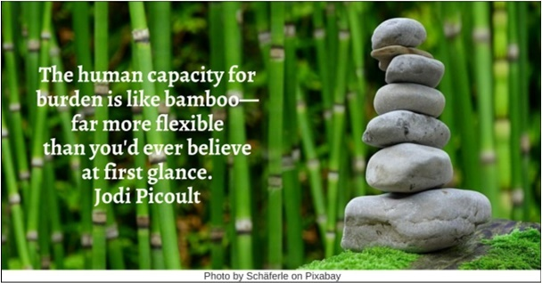

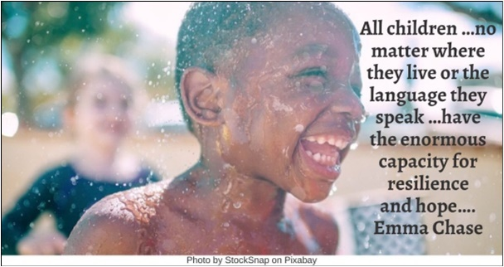

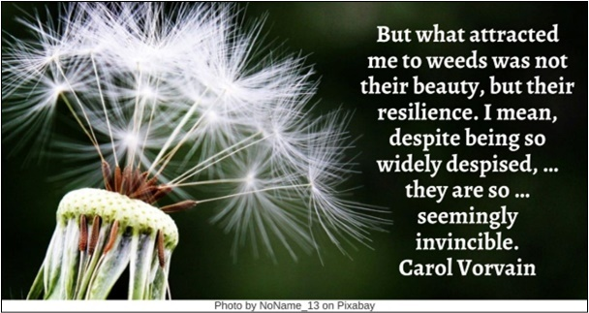

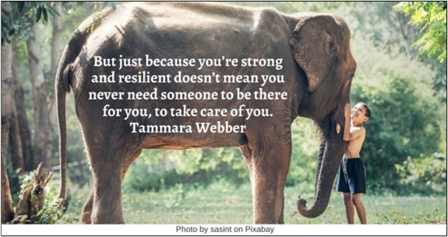

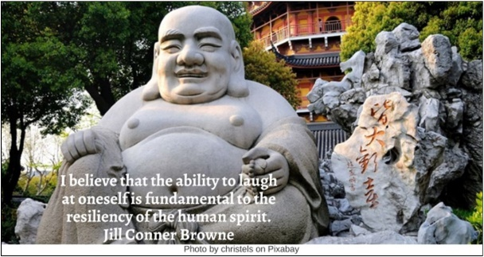



Resources for Children
2.0: Wisdom Stories
The Tapestry of Faith stories are not listed, since those are easily accessible in the curricula listed at 4.0 & 5.0:
2.1: The Framer and the Donkey by unknown (271 words)
One day a farmer's donkey fell down into a well. The animal cried piteously for hours as the farmer tried to figure out a way to get him out. Finally, he decided it was probably impossible and the animal was old and the well was dry anyway, so it just wasn't worth it to try and retrieve the donkey.
So, the farmer asked his neighbors to come over and help him cover up the well. They all grabbed shovels and began to shovel dirt into the well. At first when the donkey realized what was happening, he cried horribly.
Then, to everyone's amazement, he quieted down and let out some happy brays. A few shovel loads later, the farmer looked down the well to see what was happening and was astonished at what he saw.
With every shovel of dirt that hit his back, the donkey was shaking it off and taking a step up. As the farmer's neighbors continued to shovel dirt on top of the animal, he continued to shake it off and take a step up. Pretty soon, to everyone's amazement, the donkey stepped up over the edge of the well and trotted off!
Moral: Life is going to shovel dirt on you. The trick to getting out of the well is to shake it off and take a step up. Every adversity can be turned into a stepping stone. The way to get out of the deepest well is by never giving up but by shaking yourself off and taking a step up. What happens to you isn't nearly as important as how you react to it.
Source: https://www.encouragemint.org/words-of-encouragemint/the-farmer-and-the-donkey

2.2: A Carrot, an Egg, and Coffee Beans by Unknown (432 words)
A young woman struggling with life, went to her mother and told her how her life was miserable and hard for her. She was tired of fighting and struggling with her problems and wanted to give up.
Her mother, without saying much, took the young lady to the kitchen. She filled three pots with water. In the first pot, she placed carrots, in the second one she placed eggs, and the last she placed some ground coffee beans.
She let them sit and boil without saying a word to her daughter. The daughter wondered what her mother was trying to do while she was complaining about her life. After some time the mother turned down the burner, fished the carrots and the eggs out and placed them in a bowl. Then she ladled the coffee out into a cup. Turning to her daughter, she asked, “Dear, Tell me what do you see?”. “A Carrot, egg and coffee.” she replied.
“Look closer and feel the carrots” said the mother. The daughter noted that they were soft. The mother then asked her to take an egg and break it. The interior of the egg was hard boiled. Finally, she asked her to sip the coffee. Its rich smell brought a smile to her face.
The daughter then asked, “What does this mean, mother?”
All the three items, carrot, egg, and coffee went through the same situation , the boiling water . However, each reacted differently. The carrot was strong, hard, and unrelenting. However, after being subjected to the boiling water, it softened and became weak. The egg was fragile with the thin outer shell and its liquid interior. But after being in the boiling water, it hardened its interior. The ground coffee beans were unique, as it came to the boiling water, it changed the water and gave its incredible aroma.
“What are you?” she asked the daughter. “How do you respond in difficult situations? Are you a carrot, an egg, or a coffee bean?”
Are you a carrot that seems strong at first, but becomes soft and loses strength in adversity?
Are you an egg that starts with a malleable heart, but hardens with the heat? Did you have a fluid spirit, but as you struggled with problems, have you become hardened and stiff? Did the problem harden your free spirit?
Or are you like coffee beans? The beans that change the hot water, the adversity, into an aromatic drink. If you are like the coffee beans, when things are at their worst, you will get better and change the situation around you.
Source: https://alltimeshortstories.com/motivational-egg-carrot-coffee-beans/

2.3: The Two Wolves, a Cherokee story (233 words)
A young boy came to his Grandfather, filled with anger at another boy who had done him an injustice.
The old Grandfather said to his grandson, "Let me tell you a story. I too, at times, have felt a great hate for those that have taken so much, with no sorrow for what they do. But hate wears you down, and hate does not hurt your enemy. Hate is like taking poison and wishing your enemy would die. I have struggled with these feelings many times."
"It is as if there are two wolves inside me; one wolf is good and does no harm. He lives in harmony with all around him and does not take offence when no offence was intended. He will only fight when it is right to do so, and in the right way. But the other wolf, is full of anger. The littlest thing will set him into a fit of temper."
"He fights everyone, all the time, for no reason. He cannot think because his anger and hate are so great. It is helpless anger, because his anger will change nothing. Sometimes it is hard to live with these two wolves inside me, because both of the wolves try to dominate my spirit."
The boy looked intently into his Grandfather's eyes and asked, "Which wolf will win, Grandfather?"
The Grandfather smiled and said, "The one I feed."
Source: https://theacademy.sdsu.edu/wp-content/uploads/2015/06/two-wolves-cherokee-story.pdf

2.4: The Dream of the Olympics Realized in the Paralympics (368 words)
Peter has been swimming from the age of 3. He has won many medals in swimming events since then. He had the nickname “Dolphin!” His dream was to win an Olympic medal for his country.
One day Peter, and his father were traveling in a car to participate in a swimming event. While driving, their car met with an accident. Both he and his father were severely injured.
They were, admitted to a nearby hospital. Sadly, Peter’s father died due to a severe head injury, and Peter lost both his hands.
It took some days for him to regain consciousness. Hearing that his father was no longer with him and the pain of losing both his hands, his dreams were shattered.
After three months of treatment, he returned home. The void created by his father’s death haunted him.
Days passed, and then one day he came across an old poster created by his father. I read, “Proud to be Peter’s father. One day my son will win the Olympic medal! Seeing this, he began to cried loudly. Hearing this, his mom came and consoled him.
She said, “Peter, your father always wanted you to achieve big in swimming. And I am sure you are going to full fill his dreams”.
He replied, “Mom, how can I? Can’t you see me”.
She said, “This is not the end of the world. Go and find a way to achieve your dream. There is always a way, my Dolphin.”
Peter then started exploring the path to achieve his dream and set a medal at Paralympics as his target. Initially, it was very difficult for him during training. But he was resilient and trained hard.
Peter started participating in the para swim events. He slowly progressed and kept breaking his records. Then he started winning the events. After two years of hard work, he was selected to represent his country in the Paralympics.
Peter participated and won two gold and one silver medal for his country, with two world records.
After he returned to his home, he said to his mother, “Mom, I fulfilled father’s dream. But this is not the end!”.
He went on win multiple medals in the Para Olympics.
Source: https://winnersstory.com/short-stories-about-resilience-1/

2.5: The Roof of the World (261 words)
The Yarlung Tsangpo river is known as the roof of the world and is the highest river in the world. The river is often called …the “Everest of Rivers” because of its extreme conditions and lofty elevation. The average elevation is over 13,000 feet high. Yarlung Tsangpo starts from the Angsi Glacier in Tibet and runs across Tibet and India until it and then meets The Bay of Bengal. It has to navigate its way through multiple mountain ranges.
While leaving the Tibetan Plateau, the river forms the world’s largest and deepest canyon, Yarlung Tsangpo Grand Canyon which is much longer than the Grand Canyon in America. [This canyon is carved into granite bedrock and, in some places, it reaches down more than 17,000 feet from top to bottom, making it three times deeper than the Grand Canyon. It's also one of the world's longest canyons, stretching more than 300 miles.] The Yarlung Tsangpo river is certainly …among the most unusual and inspiring rivers of the world.
The river is stronger than the mountain. The way of the river, ever searching, ever flowing, always finds its path around the obstacle. In the flow of the river one can observe its true strength. Drawn by its pull to the sea, aided by gravity, every river seeks out its path and sometimes even creates it. The canyons are beautiful pieces of geographical art which serve as a reminder, that in nature, water cuts rock. What constitutes your strength in life? What are the values that you can rely on, to keep you flowing?
Source: https://healingforest.org/2020/07/24/resilience-examples-stories/

2.6: Faith Is Like a Walking Stick by Rev. Gary Kowalski (749 words)
How many of you like to go hiking? I have a number of walks nearby that I like. Hunger Mountain, Snake Mountain and others. Or if we don’t want to drive, my wife and I just go down to our local park where in just a few steps you can forget you’re in the city. Sometimes we bring our dog Smokey along, and Smokey isn’t as strong or fast as he used to be. But that’s okay because I’m not as young or as fast as I used to. And Smokey reminds me to slow down.
A walk in the woods isn’t a race, after all. It’s not all about seeing how fast you can go, or how quickly you can get to the end of the trail. A walk can be like a meditation, a series of moments to be aware of all the sights and sounds along the way. If you’re in too big a hurry, you forget to hear the birds sing and might not see that little mushroom growing under the tree, the one with the yellow cap.
But even when you take your time, a walk can sometimes be tough going. What if it starts to rain? And what if there’s a wet, soggy, boggy place where the stepping stones are few and far between? Well, in those cases, I’ve found a couple of things that help. First of all, it helps to have a friend or two along, because then even if it starts to pour and the raindrops are trickling down your nose, you can always sing a song together, and it’s hard to feel sorry for yourself when you’re singing an old Beatles song. And for those soggy, boggy places, if you can’t have a friend along, there’s nothing like a walking stick, which helps you keep your balance, and whether you’re walking up hill or down makes you a little steadier on your legs.
Walking sticks make me think about our faith, Unitarian Universalism, which is a little different from other religions. Because for us, life is like a long walk, or a journey. It starts when we’re little children and just learning about our world, and then grows as we grow. With each step, we’re always gathering more information and gaining more experiences, finding out about ourselves and as we explore our beliefs change. The things we imagine might be true when we’re six years old are different from the dreams we have when we’re sixty. And none of us is just certain where or how the trail ends, or what we’ll find when we finally reach the mountain top. But we know that other people have walked this way before and that gives us the hope and courage to continue on the adventure.
Now just like on a long trail, life sometimes gets a little tough and can even be scary. And that’s why it helps to have friends, and a spiritual community like this one. And, at times we start to lose our balance and begin to fall down. And then it’s handy to have a walking stick along.
Unitarian Universalism, our religion, is like a walking stick. It’s not a religion that solves all our problems. It’s not a religion that can magically lift us over the muddy places. It’s not a religion that spares us the necessity to dig deep and struggle when there’s a big boulder we have to climb over or other challenges come along. But it is a religion that can help us keep our equilibrium, that helps us keep our feet on the ground, which reminds us when the going gets hard that each of us is strong, each of us is resilient, each of us is capable, however we identify our gender, our ethnicity, our race; whether we’re big or little. And Unitarian Universalism is a faith that encourages each one of us to find and make our own beliefs—not a one-size fits all religion—but one we constantly tool and re-tool as we go.
So, this is my personal walking stick. (Show kids my stick.) It even has my initials on it, G.K. But each of you will have the opportunity to make your own stick, just the right size and weight, the right thickness so you can have a firm grip, to help you go wherever you need to go. And as Unitarian Universalists, you too can find and make a religion you can call your own.
Source: https://www.uua.org/worship/words/sermon/faith-walking-stick

2.7: Beyond Every Door by Rev. Molly Housh Gordon (373 words)
The author suggests supplementing this Time for All Ages with a PowerPoint/slide show of interesting doors and asking the kids to imagine what is on the other side of each of them...
Who here knows the book The Lion, the Witch, and the Wardrobe? Can one of the kids in the room tell me how Lucy Pevensie discovers Narnia?
Lucy looks for the perfect place to hide and opens up the door to a big wardrobe. She goes through the door and into the back of the wardrobe and suddenly she's in a whole other world! A magical world with witches and fauns and talking beavers!
Wouldn’t it be cool if there were a magical world beyond every door? When Lucy opened the door to Narnia, it didn’t look like anything special. It was just a boring door to a wardrobe full of clothes and coats, but across its threshold was magic. Lucy already had a foot in Narnia before she quite realized what was happening.
Many of the thresholds in our lives are like this: we don’t know that we’re crossing into another world until we’re already half way there.
The door of a church takes us down a pathway of growth we might never have expected.
The door of the doctor’s office suddenly opens out into life with a hard diagnosis.
A restaurant door opens onto a first date and echoes forward into the relationship of a lifetime.
A beloved person’s door closes behind you and sends you out into the world heartbroken.
The door to a library, or a gym, or a dance studio introduces you to a life’s passion you might not have otherwise discovered.
We cross these thresholds every day of our lives, for good and for ill – in joy, in sorrow, in bittersweet truth.
Truly, even our own front door is a great threshold, no matter how familiar the worlds within and without may be.... Given our lives’ reality of constant change, every day we open the same old door again, only to step out into a world that is new since the day before. In this way, there is a new world behind every door, awaiting our discovery if we will only encounter it as such.
Source: https://www.uua.org/worship/words/time-all-ages/beyond-every-door

2.8: How to Defeat Fear by Pema Chödrön (215 words)
Once there was a young warrior. Her teacher told her that she had to do battle with fear. She didn’t want to do that. It seemed too aggressive; it was scary; it seemed unfriendly. But the teacher said she had to do it and gave her the instructions for the battle. The day arrived. The student warrior stood on one side, and fear stood on the other. The warrior was feeling very small, and fear was looking big and wrathful. They both had their weapons. The young warrior roused herself and went toward fear, prostrated three times, and asked, “May I have permission to go into battle with you?” Fear said, “Thank you for showing me so much respect that you ask permission.” Then the young warrior said, “How can I defeat you?” Fear replied, “My weapons are that I talk fast, and I get very close to your face. Then you get completely unnerved, and you do whatever I say. If you don’t do what I tell you, I have no power. You can listen to me, and you can have respect for me. You can even be convinced by me. But if you don’t do what I say, I have no power.” In that way, the student warrior learned how to defeat fear.

Source: https://waldronleadership.com/defeat-fear-pema-chodron/

3.0: Children’s Books
3.1: The Hugging Tree: A Story About Resilience by Jill Neimark (Author) and Nicole Wong (Illustrator) (2015)
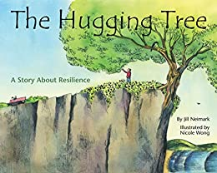
“The Hugging Tree follows tells the story of a little tree growing all alone on a cliff, by a vast and mighty sea. Through thundering storms, and the cold of winter, the tree holds fast. Sustained by the natural world and the kindness and compassion of one little boy, eventually the tree grows until it can hold and shelter others.
The resilience of the Hugging Tree calls to mind the potential in all of us: to thrive, despite times of struggle and difficulty. To nurture the little spark of hope and resolve. To dream and to grow, just where we are.” The hugging tree survives and thrives because of resilience.
Video Link: https://www.youtube.com/watch?v=CCZY_TIwhDU (4:29)

3.2: Muhammad Ali: A Champion Is Born by Gene Barretta, author and Frank Morrison, illustrator (2017)
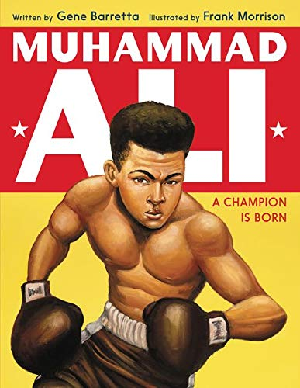
“The Louisville Lip. The Greatest. The People’s Champion. Muhammad Ali had many nicknames. But before he became one of the most recognizable faces in the world, before the nicknames and the championships, before he converted to Islam and changed his name to Muhammad Ali, he was twelve-year-old Cassius Clay riding a brand-new red-and-white bicycle through the streets of Louisville, Kentucky. One fateful day, this proud and bold young boy had that bike stolen, his prized possession, and he wouldn’t let it go. Not without a fight.
“This would be the day he discovered boxing. And a champion was born.” Ali’s life reflected incredible resilience.
Video Link: https://www.youtube.com/watch?v=db2x9vMbLP8 (14:00)

3.3: Resilience: A book to encourage resilience, persistence and to help children bounce back from challenges and adversity by Jayneen Sanders (Author) and Sofia Cardoso (Illustrator) (2017)
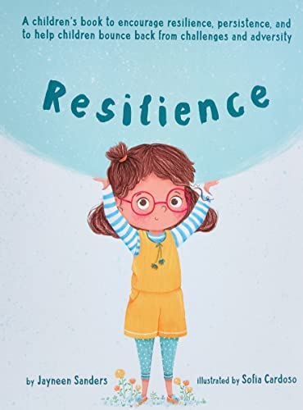
“Meet Emmi! She is resilient, independent and courageous. She always tries her best, and even when the going gets tough, Emmi never gives in.
This charming story uses verse and beautiful illustrations to model resilience, persistence, and the ability to face challenges with tenacity. Children who are resilient are brave, curious, confident and problem solvers. Nurturing these traits in our children will go a long way in helping them face the many challenges they will encounter throughout their lives.” This book illustrates how to be resilient.
Video Link: https://www.youtube.com/watch?v=23NTbIoif3I (7:07)

3.4: Ada's Violin: The Story of the Recycled Orchestra of Paraguay by Susan Hood (Author) and Sally Wern Comport (Illustrator) 2016
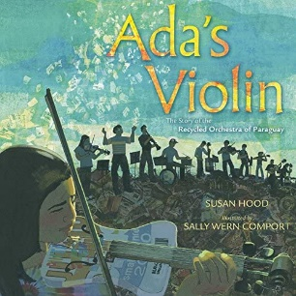
“Ada Ríos grew up in Cateura, a small town in Paraguay built on a landfill. She dreamed of playing the violin, but with little money for anything but the bare essentials, it was never an option...until a music teacher named Favio Chávez arrived. He wanted to give the children of Cateura something special, so he made them instruments out of materials found in the trash. It was a crazy idea, but one that would leave Ada—and her town—forever changed. Now, the Recycled Orchestra plays venues around the world, spreading their message of hope and innovation.” Creating instruments out of trash and then learning to play on them are wonderful examples of resilience.
Video Link: https://www.youtube.com/watch?v=WTfchBlASsc (10:32)
60 minutes—The Recyclers: From trash comes triumph: https://www.youtube.com/watch?v=YxUuKthY1dQ (13:19)

3.5: Henry's Freedom Box: A True Story from the Underground Railroad by Ellen Levine, author and Kadir Nelson, illustrator (2007)
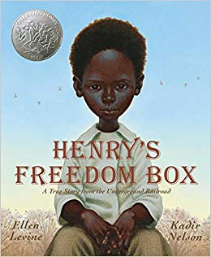
“Henry Brown doesn't know how old he is. Nobody keeps records of slaves' birthdays. All the time he dreams about freedom, but that dream seems farther away than ever when he is torn from his family and put to work in a warehouse. Henry grows up and marries, but he is again devastated when his family is sold at the slave market. Then one day, as he lifts a crate at the warehouse, he knows exactly what he must do: He will mail himself to the North. After an arduous journey in the crate, Henry finally has a birthday -- his first day of freedom.” An ingenious plan to achieve freedom demonstrated resilience.
Video Link: https://www.youtube.com/watch?v=L6rf9bxDK1o (8:52)

3.6: Red Kite, Blue Kite by Ji-li Jiang (Author) and Greg Ruth (Illustrator) (2013)
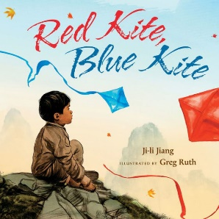
“When Tai Shan and his father, Baba, fly kites from their roof and look down at the crowded city streets below, they feel free, like the kites. Baba loves telling Tai Shan stories while the kites--one red, and one blue--rise, dip, and soar together. Then, a bad time comes. People wearing red armbands shut down the schools, smash store signs, and search houses. Baba is sent away, and Tai Shan goes to live with Granny Wang. Though until Baba can be free again, like the kites.
“Inspired by the dark time of the Cultural Revolution in China, this is a soaring tale of hope that will resonate with anyone who has ever had to love from a distance.” The ritual of flying kites with his Baba and that memory encouraged resilience during his Baba’s absence.
Video Link: https://www.youtube.com/watch?v=HUoaZB7KGS0 (9:54)

3.7: Singing Away the Dark by Caroline Woodward (Author) and Julie Morstad (Illustrator) 2010
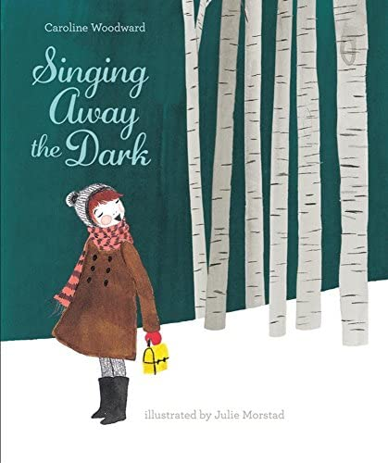
“On a dark winter’s morning, a little girl has to trudge a mile to catch the school bus. Will she be able to sing her way through the shadows? …singing away the dark was part of a six-year-old’s rural school-going routine.” Singing away the dark is a technique to address fear. It illustrates resilience.
Video Link: https://www.youtube.com/watch?v=d3E_lsya0xA (3:54)

3.8: The Thing Lou Couldn't Do by Ashley Spires (2017)
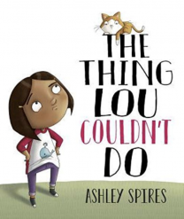
“‘Lou and her friends are BRAVE adventurers. They run FASTER than airplanes. They build MIGHTY fortresses. They rescue WILD animals.’ But one day, when they're looking for a ship to play pirates in, Lou's friend has an idea: ‘Up there! The tree can be our ship!’ ‘Ummm ...’ says Lou. This is something new. Lou has never climbed a tree before, and she's sure she can't do it. So, she tries to convince her friends to play a not-up-a-tree game. When that doesn't work, she comes up with reasons for not joining them—her arm is sore, her cat needs a walk, you shouldn't climb so soon after eating. Finally, she tells herself she doesn't want to climb the tree. But is that true, or is this brave adventurer just too afraid to try? Overcoming fear helps to build resilience.
Video Link: https://www.youtube.com/watch?v=BNiLTJD3xx8 (4:43)

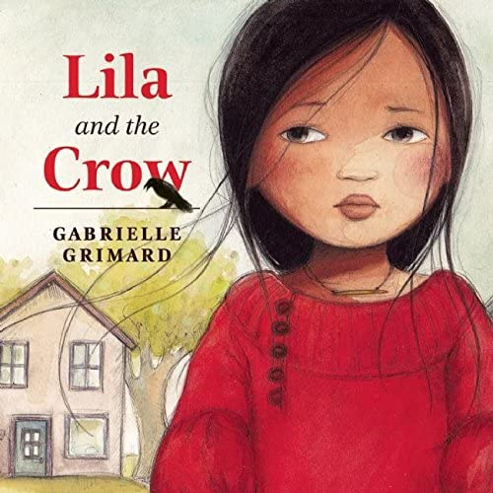
3.9: Lila and the Crow by Gabrielle Grimard (2016)
“Lila has just moved to a new town and can't wait to make friends at school. But on the first day, a boy points at her and shouts: “A crow! A crow! The new girl's hair is black like a crow!” The others whisper and laugh, and Lila's heart grows as heavy as a stone.
“The next day, Lila covers her hair. But this time, the boy points at her dark skin. When she covers her face, he mocks her dark eyes. Now every day at school, Lila hides under her turtleneck, dark glasses, and hat. And every day when she goes home, she sees a crow who seems to want to tell her something. Lila ignores the bird and even throws rocks at it, but it won't go away.
‘Meanwhile, the great autumn festival is approaching. While the other kids prepare their costumes, Lila is sadder and lonelier than ever. At her lowest point of despair, a magical encounter with the crow opens Lila's eyes to the beauty of being different and gives her the courage to embrace her true self proudly.” Resilience is often encouraged by another person being supportive.
Video Link: https://www.youtube.com/watch?v=HJIIzlGkbz8 (6:49)

3.10: You Hold Me Up by Monique Gray Smith (Author) and Danielle Daniel (Illustrator) (2017)

“…Monique Gray Smith wrote You Hold Me Up to prompt a dialogue among young people, their care providers and educators about reconciliation and the importance of the connections children make with others. With vibrant illustrations from celebrated artist Danielle Daniel, this is a foundational book about building relationships, fostering empathy and encouraging respect between peers, starting with our littlest citizens.” Holding each other up increases resilience.
Video Link: https://www.youtube.com/watch?v=QPDeJTCERms (2:03)

3.11: I Am Courage: A Book of Resilience by Susan Verde, author and Peter H. Reynolds, illustrator (2021)
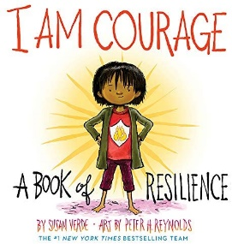
“When we picture someone brave, we might think they’re fearless; but real courage comes from feeling scared and facing what challenges us anyway. When our minds tell us ‘I can’t,’ we can look inside ourselves and find the strength to say, ‘Yes, I CAN!’” Saying “I can” is being resilient.
Video Link: https://www.youtube.com/watch?v=WF35l1J1Ay4 (2:59)

3.12: The Resilient Sloth: A Children’s Book About Building Mental Toughness, Resilience, and Learning to Deal with Obstacles (2020) by Charlotte Dane (Author) and Adam Riong (Illustrator)
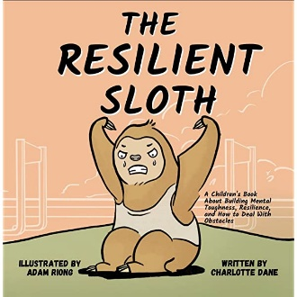
“Sloth routinely impressed his family, friends, and teachers with his ability to look past hardships and never give up, even when the going was tough. He was just so reliable. Whatever the difficulties, he powered through them. But he wasn’t always that way. Once upon a time, Sloth’s friend Fox showed him a simple and small tip that completely changed his approach. Find out what this tip is, and how to use it to instill emotional maturity, mental toughness, and resilience in your growing child!” Fox’s suggestion gave Sloth perspective and increased his resilience.
Video Link: https://www.youtube.com/watch?v=YR-s5aChLbI (7:07)

3.13: I Can Do Hard Things: Mindful Affirmations for Kids by Gabi Garcia (Author) and Charity Russell (Illustrator) (2018)
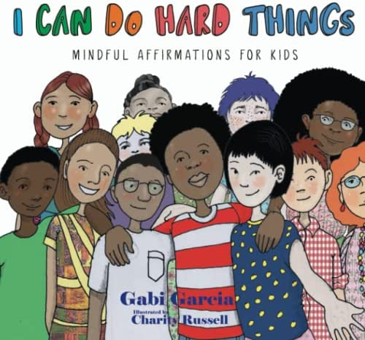
“What kids tell themselves matters! It becomes their inner voice. It can help them connect with their power within. Help your child tap into their inner strength and resilience when challenges arise. I Can Do Hard Things introduces children to the practice of using mindful affirmations for support and encouragement when they need it.” Mindful affirmations build confidence and resilience.
Video Link: https://www.youtube.com/watch?v=4X4yNlSNrEs (4:14)

3.14: A Thousand No's: A growth mindset story of grit, resilience, and creativity by DJ Corchin (Author) and Dan Dougherty (Illustrator) (2020)

“There was a little girl who had a great idea. She had the most amazing, superb, best idea ever! NO? Wait, what do you mean NO? NO again? What is she supposed to do with all these NO's? NO after NO after NO come the little girl's way, twisting and squishing her idea. But by persevering, collaborating and using a little imagination, all those NO's become the building blocks for the biggest YES ever! A Thousand NO's is a story about perseverance and innovation.” Being able to persevere in the face of NO builds resilience.
Video Link: https://www.youtube.com/watch?v=m17R-V25o7U (3:33)

3.15: I Am!: Affirmations for Resilience by Bela Barbosa (Author) and Edel Rodriguez (Illustrator) (2020)
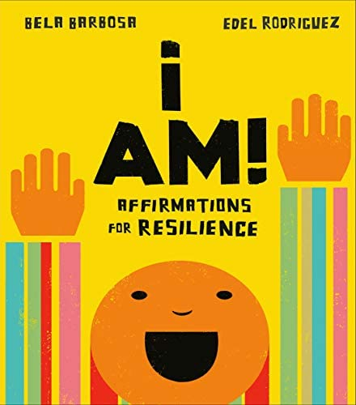
“This brightly hand-lettered board book empowers young readers to lift themselves up! Ten relatable emotions are each followed by a centering exercise and a positive affirmation to be recited, as a practice in mindfulness. Young readers are encouraged to find their inner strength by recognizing and addressing their emotions, instilling a sense of power and self-confidence.” Resilience is a quality that can be built by increasing a sense of power and self-confidence.” Affirmations and other practices can build resilience.
Video Link: https://www.youtube.com/watch?v=VNGspkcrbQY (5:16)

3.16: Bounce Back! by Cheri J. Meiners M.Ed. (Author) and Elizabeth Allen (Illustrator) (2014)
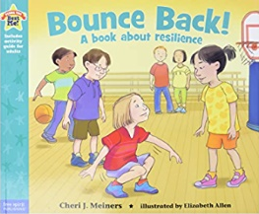
Being able to bounce back from a setback demonstrates resilience.
Video Link: https://www.youtube.com/watch?v=7740VOUb6js (2:37)

3.17: When Bad Things Happen: A Guide to Help Kids Cope by Ted O'Neal (Author) and R W Alley (Illustrator) (2003)
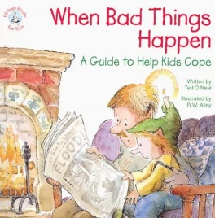
This book “helps parents deal with their children's fears and sadness.” Coping skills are essential to building resilience.
Video Link: https://www.youtube.com/watch?v=SwFzFl4XdJw (5:00)

3.18: After the Fall: How Humpty Dumpty Got Back Up Again by Dan Santat (2017)
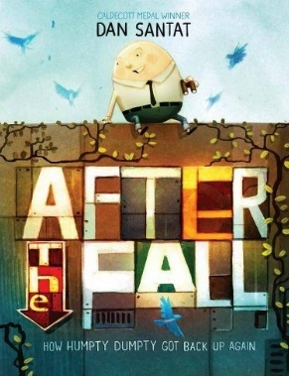
“Humpty Dumpty hasn’t been the same since he fell off the wall and was put back together again. He used to love being in high places, close to the birds, but now he can’t even stand being on the top bunk. He misses out on a lot of fun as a result of his fear of heights. Then he’s struck with an idea that unintentionally leads him right back to the wall, the site of his great fall. He forces himself to the top, and when he arrives, the most amazing thing happens. Humpty Dumpty transforms in a way no one could have imagined!” Humpty Dumpty eventually demonstrates his resilience by climbing ONE step at a time.
Video Link: https://www.youtube.com/watch?v=HvWwBLt4dbg (4:26)

3.19: I Am Not Afraid to Fail by Daniel Kenney (Author) and Sumit Roy (Illustrator) (2018)
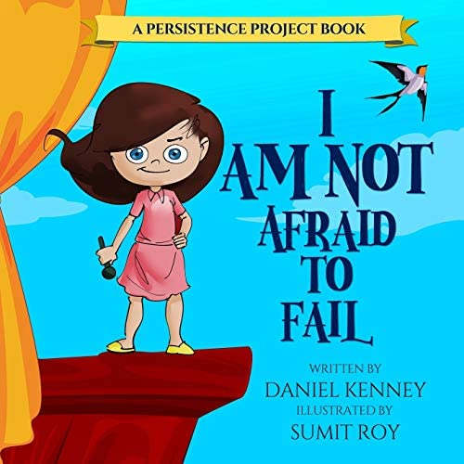
Learning that failure is a normal and natural part of life builds character and encourages trying new things. Overcoming the fear of failure builds resilience.
Video Link: https://www.youtube.com/watch?v=Z8H_QDSjDHY (5:32)

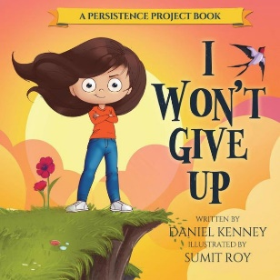
3.20: I Won't Give Up by Daniel Kenney (Author) and Sumit Roy (Illustrator) (2018)
“With funny and silly pictures, and a simple but positive message, this book teaches children about the importance of not giving up.” Refusing to give up helps to build resilience.
Video Link: https://www.youtube.com/watch?v=jE-kT6vf4Kc (3:02)

3.21: You Can Face Your Fears by Daniel Kenney (Author) and Sumit Roy (Illustrator) (2018)
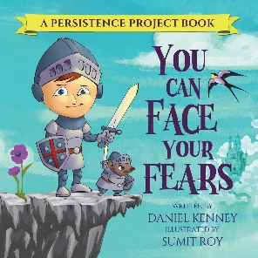
“Facing fear is hard. Especially for kids! The fact is that everybody gets scared. EVERYBODY! And learning to face one's fears is essential….” Facing fear strengthens resilience.
Video no longer available.

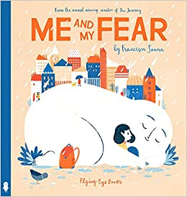
3.22: Me and My Fear by Francesca Sanna (Author) (2018)

“When a young immigrant girl has to travel to a new country and start at a new school, she is accompanied by her Fear who tells her to be alone and afraid, growing bigger and bigger every day with questions like ‘how can you hope to make new friends if you don’t understand their language?’ But this little girl is stronger than her Fear. …This book shows us the importance of sharing your Fear with others--after all, everyone carries a Fear with them, even if it’s small enough to fit into their pocket!” Talking about our fears encourages resilience.

Video Link: https://www.youtube.com/watch?v=yXcCZvxpym8 (3:46)

3.23: Take a Deep Breath by Sue Graves (Author), Desideria Guicciardini (Illustrator) (2013)

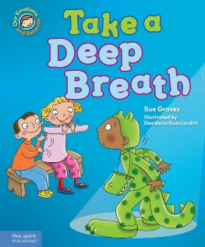
“Lucy is afraid of dogs, Josh doesn’t like to go in the pool, Dan doesn’t want the nurse to touch his bruised knee, and Ben is afraid to go on stage. When something scares them, they can take a deep breath and feel brave enough to get through their ordeals.” Taking a deep breath and centering oneself can overcome fear and build resilience.

Video Link: https://www.youtube.com/watch?v=jRAbh39j4ZA (5:03)

3.24: When You Are Brave by Pat Zietlow Miller, author and Eliza Wheeler, illustrator (2019)
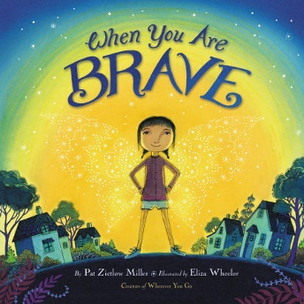
“An inspiring picture book affirmation about having courage even in difficult times, because some days, when everything around you seems scary, you have to be brave.
“Saying goodbye to neighbors. Worrying about new friends. Passing through a big city. Seeing a dark road ahead. In these moments, a young girl feels small and quiet and alone. But when she breathes deeply and looks inside herself, a hidden spark of courage appears, one she can nurture and grow until she glows inside and out.” Confronting difficult experiences with bravery builds resilience.
Video Link: https://www.youtube.com/watch?v=qaXJCjACms0 (5:19)

3.25: The Very Brave Lion by Wendy Ravenhill, author and Cee Biscoe, illustrator (2016)
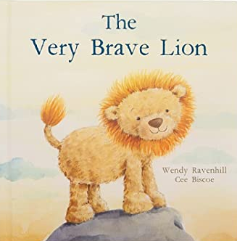
“In ‘The Very Brave Lion,’ a little cub talks to his father about growing up. He learns it’s OK to be scared sometimes, and that kindness and love are all that matters.” Understanding that sometimes it is okay to be afraid can help build resilience.
Video Link: https://www.youtube.com/watch?v=mgQDSI4QokE (3:35)

3.26: The Courageous Dragon by Kirsten Irving, author and Gavin Scott, illustrator (2019)
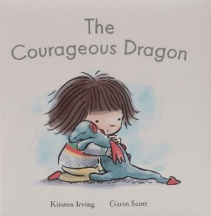
“Sometimes life can be scary but a true friend can help us be brave. In this gentle adventure a bright, bold dragon helps to make frightening things exciting!” Resilience can be built through connections with others.
Video Link: https://www.youtube.com/watch?v=ewupCkkUtjo (2:34)

3.27: The Lion Inside by Rachel Bright, author and Jim Field, illustrator (2016)

“‘That day they BOTH learned, that, no matter your size, we all have a mouse AND a lion inside.’ A mouse feels small and insecure and determines that what he needs to do is learn how to roar like a lion. He knows he has to act brave when he approaches a lion to learn how. In a hilarious turn of events, the lion is afraid of mice! The mouse comforts the lion, they become friends, and we learn that there’s a lion and a mouse inside all of us.” Realizing that everyone has a mouse and a lion inside promotes resilience.
Video Link: https://www.youtube.com/watch?v=H019G18irW0 (6:21)

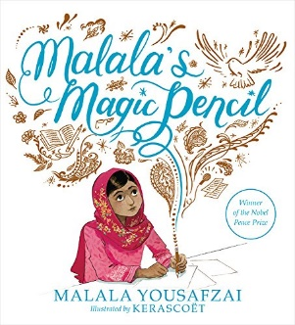
3.28: Malala’s Magic Pencil by Malala Yousafzai, author and Kerascoët, illustrator (2017)
“As a child in Pakistan, Malala made a wish for a magic pencil. She would use it to make everyone happy, to erase the smell of garbage from her city, to sleep an extra hour in the morning. But as she grew older, Malala saw that there were more important things to wish for. She saw a
world that needed fixing. And even if she never found a magic pencil, Malala realized that she could still work hard every day to make her wishes come true.” Malala has demonstrated incredible resilience.
Video Link: https://www.youtube.com/watch?v=zVgtqDDXWVg (10:09)

3.29: A Little SPOT of Courage: A Story About Being Brave by Diane Alber (2020)
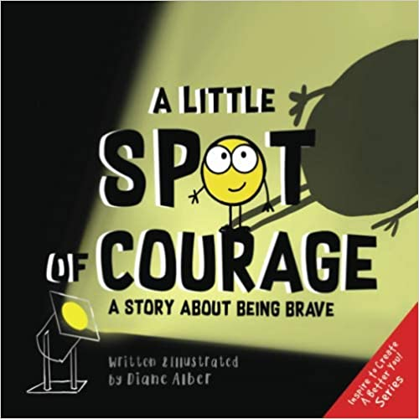
“What is courage? You might think of super hero when you hear COURAGE, but all of us can do small and big acts of COURAGE every day! A Little SPOT of Courage will show you some ways you can grow your COURAGE SPOT From trying out for a basketball team to helping someone when they are being treated unkind to much more!” Growing the courage spot builds resilience.
Video Link: https://www.youtube.com/watch?v=0RvnpZlLl4o (9:24)

3.30: Be Brave, Little Penguin by Giles Andreae, author and Guy Parker-Rees, illustrator (2017)
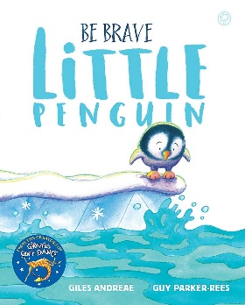
“Little Penguin Pip-Pip would love to join in with all his friends swimming in the sea, but there’s just one problem… he’s scared of water. Can Pip-Pip overcome his fears and finally take the plunge? This irresistible story shows that sometimes all it takes is a little bit of encouragement—and a whole lot of heart—to finally make that leap and be BRAVE!” Making the leap shows resilience.
Video Link: https://www.youtube.com/watch?v=-UQ-vvC6psE (3:38)

3.31: Courageous People Who Changed the World by Heidi Poelman, author and Kyle Kershner, illustrator (2018)
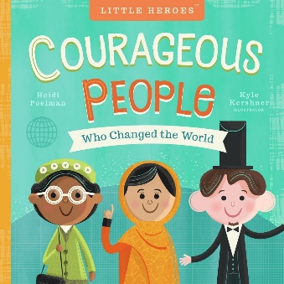
“From the intrepid efforts of Susan B. Anthony to the quiet courage of Rosa Parks, Courageous People Who Changed the World is a young child’s first introduction to the brave people who fought to make the world a better place. Simple text and adorable illustrations tell the contributions of eight champions of freedom: Abraham Lincoln, Rosa Parks, Susan B. Anthony, Malala Yousafzai, Harriet Tubman, William Wilberforce, Mahatma Gandhi, and Martin Luther King Jr. A quote from each individual is included on each spread along with colorful, delightful artwork.” Understanding the lives of courageous people show children paths to resilience.
Video Link: https://www.youtube.com/watch?v=IJPDoggyR58 (8:57)

3.32: Brave As Can Be: A Book of Courage by Jo Witek, author and Christine Roussey, illustrator (2015)
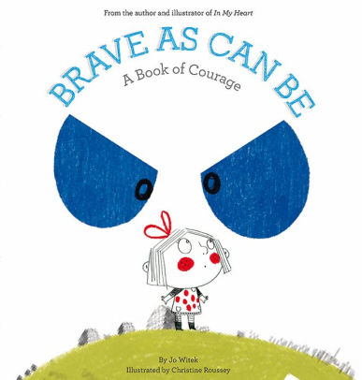
“The life of a child can be full of frightening things: the dark, the neighbor’s dog, and thunderstorms, just to name a few. As children get older, they begin to feel braver around these everyday events, but how do they build this newfound confidence?
“In this lyrical, insightful picture book, an older sister explains to her younger sister all the things she used to be afraid of, along with some tricks to help, whether it’s a special blanket for bedtime or singing during a storm. Now, big sister assures little sister, the fears that once felt as big as a mountain feel as minuscule as a speck of dust.” Having someone help you face fear builds resilience.
Video Link: https://www.youtube.com/watch?v=_i4L2mITBfE (4:45)

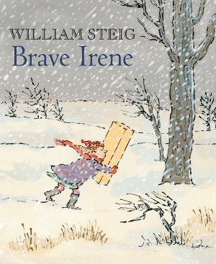
3.33: Brave Irene by William Steig (1986)
“Brave Irene is Irene Bobbin, the dressmaker’s daughter. Her mother, Mrs. Bobbin, isn’t feeling so well and can’t possibly deliver the beautiful ball gown she’s made for the duchess to wear that very evening. So plucky Irene volunteers to get the gown to the palace on time, in spite of the fierce snowstorm that’s brewing-- quite an errand for a little girl.
“But where there’s a will, there’s a way, as Irene proves in the danger-fraught adventure that follows. She must defy the wiles of the wicked wind, her most formidable opponent, and overcome many obstacles before she completes her mission. Irene’s perseverance in the face of the storm illustrates her resilience.
Video Link: https://www.youtube.com/watch?v=qVxjBvnaEyA (10:12)

3.34: You Are Brave by Todd Snow, author and Melodee Strong, illustrator (2007)
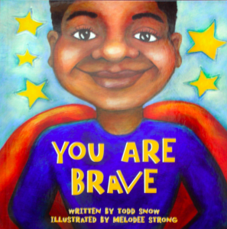
“Every child is brave in his or her own way. With simple words and vivid illustrations that relate to children’s everyday lives, You Are Brave lets very young children know that bravery is about all kinds of things: walking and running, meeting new people, letting friends play with your toys, trying new foods, and more.” Everyday activities can help build resilience.
Video Link: https://www.youtube.com/watch?v=355QEvaaUDg (1:50)

3.35: Dare to Be Brave: The Magic of Thinking Big by Eevi Jones, author and Mel Schroeder, illustrator (2019)
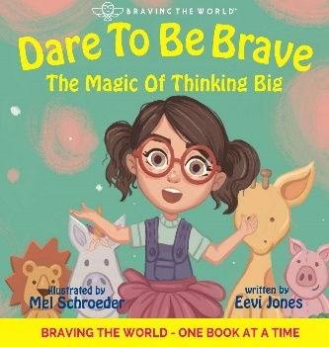
“Meet Sally O’Nelly, / a brave little girl. / Freckled and kind, / out to take on the world.
“‘Fears,’ she ponders, / ‘are funny ol’ things! / Meant to keep us safe, / yet clipping our wings!’
“Encouraging our little ones to think big, this beautifully illustrated children’s book celebrates the feats of growing into strong, resilient little souls that are not afraid to try, persevere, show strength, and to make mistakes.” Dealing with fear increases resilience.
Video Link: https://www.youtube.com/watch?v=KieThsfxai4 (4:33)

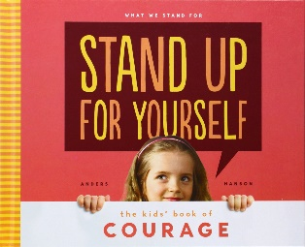
3.36: Stand Up for Yourself: The Kids’ Book of Courage by Anders Hanson (2014)
“Get the courage to stand up for what you believe in! Stand Up for Yourself: the Kids’ Book of Courage will teach kids to try something new, ask for help, show their talents, share their feelings and tell the truth. This book will show kids how to use compassion, respect, responsibility, and honesty with those around them.” Standing up for oneself is an illustration of resilience.
Video Link: https://www.youtube.com/watch?v=5TQ35tuK55M (2:50)

3.37: The Day You Begin by Jacqueline Woodson, author and Rafael López, illustrator (2018)
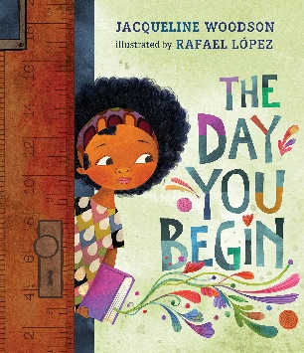
“There are many reasons to feel different. Maybe it’s how you look or talk, or where you’re from; maybe it’s what you eat, or something just as random. It’s not easy to take those first steps into a place where nobody really knows you yet, but somehow you do it.
“Jacqueline Woodson’s lyrical text and Rafael López’s dazzling art reminds us that we all feel like outsiders sometimes-and how brave it is that we go forth anyway. And that sometimes, when we reach out and begin to share our stories, others will be happy to meet us halfway.” Taking the next step, despite feeling like an outsider, is a path to resilience.
Video Link: https://www.youtube.com/watch?v=U02y5gSIDOs (4:51)

3.38: The Year We Learned to Fly by Jacqueline Woodson, author and Rafael López, illustrator (2022)
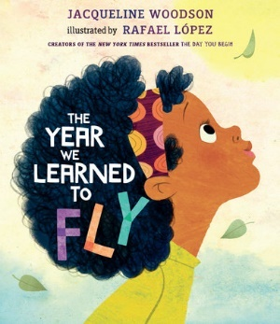
“On a dreary, stuck-inside kind of day, a brother and sister heed their grandmother’s advice: ‘Use those beautiful and brilliant minds of yours. Lift your arms, close your eyes, take a deep breath, and believe in a thing. Somebody somewhere at some point was just as bored you are now.’ And before they know it, their imaginations lift them up and out of their boredom. Then, on a day full of quarrels, it’s time for a trip outside their minds again, and they are able to leave their anger behind. This precious skill, their grandmother tells them, harkens back to the days long before they were born, when their ancestors showed the world the strength and resilience of their beautiful and brilliant minds.” Imagination is an ability that can build resilience.
Video Link: https://www.youtube.com/watch?v=JIyxqKS0wqk (4:31)

3.39: Courage by Bernard Waber (2002)
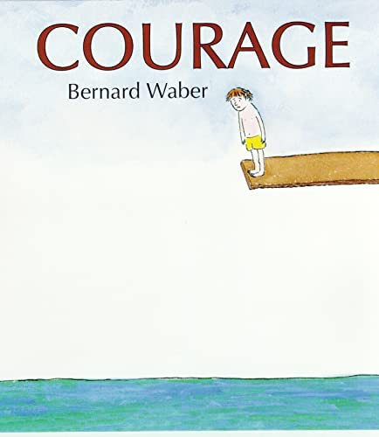
“What is courage? Certainly, it takes courage for a firefighter to rescue someone trapped in a burning building, but there are many other kinds of courage too. Everyday kinds that normal, ordinary people exhibit all the time, like ‘being the first to make up after an argument,’ or ‘going to bed without a nightlight.’ [The book] …explores the many varied kinds of courage and celebrates the moments, big and small, that bring out the hero in each of us.” Even the smallest acts of courage contribute to resilience.
Video Link: https://www.youtube.com/watch?v=7wtOxPXKmG0 (4:45)

3.40: When Worry Takes Hold by Liz Haske, author and Insong Nam, illustrator (2017)
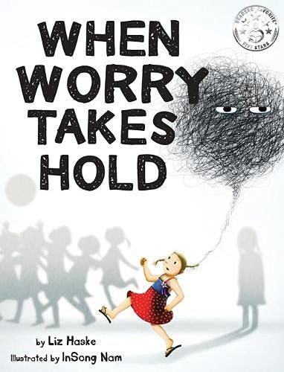
“One night just before the lights went out, Worry snuck into Maya’s mind. Worry grew bigger and bigger until there was no space left for anything else. Just darkness and fear. Join Maya as she finds Courage, through the form of a calming breath, and learns how to break free from Worry’s hold.” If Worry is not met head on, it can grow and become crippling. Facing worry requires resilience and it grows resilience.
Video Link: https://www.youtube.com/watch?v=3gqWyY6eKOg (7:38)

3.41: Brave Girl: Clara and the Shirtwaist Makers’ Strike of 1909 by Michelle Markel, author and Melissa Sweet, illustrator (2013)
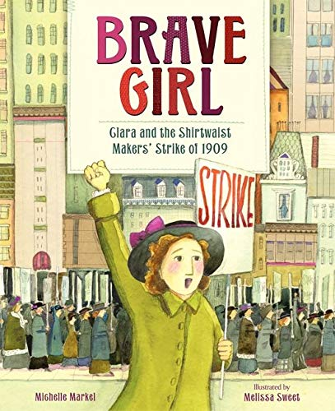
“The true story of the young immigrant who led the largest strike of women workers in U.S. history. This picture book biography about the plight of immigrants in America in the early 1900s and the timeless fight for equality and justice should not be missed.
“When Clara arrived in America [from Ukraine], she couldn’t speak English. She didn’t know that young women had to go to work, that they traded an education for long hours of labor, that she was expected to grow up fast.
“But that didn’t stop Clara. She went to night school, spent hours studying English, and helped support her family by sewing in a shirtwaist factory.
“Clara never quit, and she never accepted that girls should be treated poorly and paid little. Fed up with the mistreatment of her fellow laborers, Clara led the largest walkout of women workers the country had seen.
“From her short time in America, Clara learned that everyone deserved a fair chance. That you had to stand together and fight for what you wanted. And, most importantly, that you could do anything you put your mind to.” Clara Lemlich exhibited extraordinary resilience by never quitting and leading the strike.
Video Link: https://www.youtube.com/watch?v=RxbHVOUuSZI (10:29)

3.42: The Youngest Marcher: The Story of Audrey Faye Hendricks, a Young Civil Rights Activist by Cynthia Levinson, author and Vanessa Brantley-Newton, illustrator (2017)
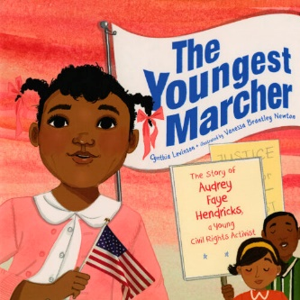
“Meet the youngest known child to be arrested for a civil rights protest in Birmingham, Alabama, 1963, in this moving picture book that proves you’re never too little to make a difference.
“Nine-year-old Audrey Faye Hendricks intended to go places and do things like anybody else.
“So, when she heard grown-ups talk about wiping out Birmingham’s segregation laws, she spoke up. As she listened to the preacher’s words, smooth as glass, she sat up tall. And when she heard the plan—picket those white stores! March to protest those unfair laws! Fill the jails! — she stepped right up and said, I’ll do it! She was going to j-a-a-il!
“Audrey Faye Hendricks was confident and bold and brave as can be, and hers is the remarkable and inspiring story of one child’s role in the Civil Rights Movement.” Audrey Faye Hendricks demonstrated resilience by marching, and then by enduring the conditions of being in jail for a week.
Video Link: https://www.youtube.com/watch?v=wMp2VAPYhgo (14:10)

3.43: Lizzie Demands a Seat!: Elizabeth Jennings Fights for Streetcar Rights by Beth Anderson, author and E. B. Lewis, illustrator (2020)
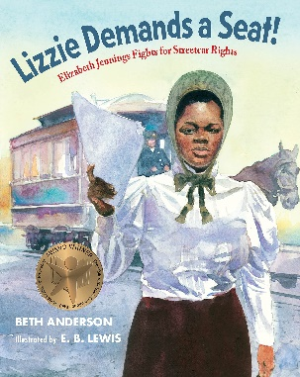
“In 1854, Elizabeth ‘Lizzie’ Jennings, an African American schoolteacher, fought back when she was unjustly denied entry to a New York City streetcar, sparking the beginnings of the long struggle to gain equal rights on public transportation.
“One hundred years before Rosa Parks took her stand, Elizabeth ‘Lizzie’ Jennings tried to board a streetcar in New York City on her way to church. Though there were plenty of empty seats, she was denied entry, assaulted, and threatened all because of her race—even though New York was a free state at that time. Lizzie decided to fight back. She told her story, took her case to court—where future president Chester Arthur represented her--and won! Her victory was the first recorded in the fight for equal rights on public transportation, and Lizzie’s case set a precedent.” Elizabeth ‘Lizzie’ Jennings showed resilience by fighting and winning her court case to defend her rights.
Video Link: https://www.youtube.com/watch?v=F2g-5kjccMU (12:56)

4.0: Curriculum & Theme-Based Classroom Activities for Children

from Tapestry of Faith

4.1: Chalice Children: A Program about Our Unitarian Universalist Community for Preschoolers
4.1.1: Session 22: Imagination
Link: https://www.uua.org/re/tapestry/children/chalicechildren/session22
Imagination is an important tool in drawing on and building resilience. The story
Journey by Aaron Becker (2013) at https://www.youtube.com/watch?v=FMtc_QFIu9Q (2:57) is a wonderful example. See also Teaching Resources https://www.teachingideas.co.uk/library/books/journey
“Participants will:
- Express their imagination through art
- Experience a connection between imagination and creativity
- Understand that people of all ages can use their imagination to wonder and to express feelings.”
4.1.2: Session 23: My Shadow
Link: https://www.uua.org/re/tapestry/children/chalicechildren/session23
Learning to face our fears is a powerful and essential element of resilience.
“Participants will:
- Reduce their fears by playing with shadows and talking about what they are afraid of
- Be reminded that they can ask questions about things they do not understand
- Connect the story they read in this session with the fact that all people are afraid sometimes.”
4.1.3: Session 27: Teddy Bear Month — Lost!
Link: https://www.uua.org/re/tapestry/children/chalicechildren/session27
Learning to face our fears is a powerful and essential element of resilience.
“Participants will:
- Experience comfort as they share with the group their fears of and feelings about being lost
- Understand that fear is a feeling everyone shares and that it helps to talk about it.”

4.2: Creating Home: A Program on Developing a Sense of Home Grounded in Faith for Grades K-1
4.2.1: Session 2: Symbols of Faith
Link: https://www.uua.org/re/tapestry/children/home/session2
Given its history, the flaming chalice is a symbol of resilience.
“Participants will:
- Create a personal faith symbol or decorate a chalice
- Construct a chalice as a symbol of their faith home to use in their family home
- Listen and interact with the story, Flame of Learning, Chalice of Love. Explore the meaning of the components of the chalice symbol
- Learn the hymn, Spirit of Life
- Create personal symbols of faith
- Optional: Internalize the chalice story by participating in a Faith in Action project involving refugees”
4.2.2: Session 7: Book of Ruth
Link: https://www.uua.org/re/tapestry/children/home/session7
The relationship between Ruth and Naomi & Owen and Mzee are amazing examples of friendship. Ruth exhibited both resilience and the fact that Mzee allowed Owen to bond with him showed a kind of resilience.
“Participants will:
- Have an opportunity to share personal stories about moving and re-establishing home
- Hear and reflect upon stories of others who have moved and re-established home
- Play a game centered on making pairs, connecting identical and then related images of objects and people
- Make a bracelet to give to a friend”
4.2.3: Session 10: Tango
Link: https://www.uua.org/re/tapestry/children/home/session10
In the story, “A Penguin Family,” Roy and Silo exhibited resilience in hatching the egg and caring for Tango.
“Participants will:
- Play a dancing game in which they choose partners
- Honor diverse families by making badges recognizing family members and their roles
- Through a story about Tango and her family, learn about family diversity
- Identify some of the elements that bond families
- Discuss how we enter faith families
- Affirm their sense of belonging by telling stories about entering and belonging in their faith family …
- Learn that people fill more than one role in a family.”
You can also watch a video reading of the book, “And Tango makes Three” at https://www.youtube.com/watch?v=bGZHD4SKmQU (6:36). This book is also available in print and on Kindle.

4.3: Wonderful Welcome: A Program for Children Grades K-1
4.3.1: Session 9: The Gift of Mutual Caring
Link: https://www.uua.org/re/tapestry/children/welcome/session9
In the story of St. Francis and the Wolf, the wolf shows considerable resilience as, finally, do the townspeople.
Participants will:
- Learn that some animals have been trained to assist people with special needs and how these working animals are different from pets
- Understand how working animals exemplify care between species, an intangible gift the children can give and receive
- Explore their own interactions with animals as pets, at a zoo, in books or electronic media, or in nature
- Identify elements of a mutual caring relationship between a human and an animal, including responsibility, affection, loyalty, and help
- Connect caring relationships between humans and animals with the larger concept of the interdependent web of life, the seventh Unitarian Universalist Principle
- Make gifts for animal friends and/or sell dog biscuits to raise funds for a guide dog school or a no-kill shelter.

4.4: Love Surrounds Us: A Program on the UU Principles and Beloved Community for Grades K-1
4.4.1: Session 11: Hear Our Voices
Link: https://www.uua.org/re/tapestry/children/lovesurrounds/session11
Ruby Bridges (1954-) demonstrated incredible resilience when she integrated William Frantz Elementary School in 1960. See a video of “The Story of Ruby Bridges” below.
“Participants will:
- Hear a story about a young girl who took the initiative to help when she saw a basic unmet need
- Learn regarding the Unitarian Universalist fifth Principle, that everyone deserves a say about the things that concern them
- Consider how they can make a difference in others’ lives even with what we think are small actions”
- The Story of Ruby Bridges by Robert Coles, author & George Ford, illustrator. “The year is 1960, and six-year-old Ruby Bridges and her family have recently moved from Mississippi to New Orleans in search of a better life. When a judge orders Ruby to attend first grade at William Frantz Elementary, an all-white school, Ruby must face angry mobs of parents who refuse to send their children to school with her.” Video Link: https://www.youtube.com/watch?v=E5iL7H-S99s (11:39)
- Ruby Bridges speaks: https://www.youtube.com/watch?v=ajE9G4aUJRA (2:00)
4.4.2: Session 12: A Peaceful and Fair World
Link: https://www.uua.org/re/tapestry/children/lovesurrounds/session12
In the story, Supriya's Bowl, Supriya’s resilience was demonstrated by continually gathering food in her begging bowl to feed the hungry.
See “Supriya's Bowl,” from “Rhinos and Raspberries” at https://www.youtube.com/watch?v=XVtuKDXwMHA (8:16).
“Participants will:
- Engage with a story of a community caring for one another
- Connect receiving and giving as they learn that a bowl is used for both
- Identify four basic human needs in relationship to the sixth Principle, “working for a peaceful, fair, and free world”
- Become confident, empowered peacemakers who act in accord with our sixth Principle.”
4.4.3: Session 16: Our UU Principles
Link: https://www.uua.org/re/tapestry/children/lovesurrounds/session16
In the story, “Angel of the Battlefield, Clara Barton,” Clara Barton (1821-1912) demonstrated resilience as a teacher and a nurse.
See Clara Barton for Kids at https://www.youtube.com/watch?v=ngI1L6_Z4pE (7:57).
“Participants will:
- Experience the story of Clara Barton, a Universalist whose life and accomplishments reflect our Principles
- Connect the UU Principles as a set of guiding affirmations for living, surrounded by love, in community
- Engage in putting parts together to understand the whole.”

4.5: World of Wonder: A Program on the Seven Principles of Unitarian Universalism for Grades K-1
4.5.1: Session 3: Thanks Be for Trees!
Link: https://www.uua.org/re/tapestry/children/wonder/session3
In the story, “Amrita's Tree,” Amrita’s resilience allows her to seek help and confront the woodcutters.
Watch the story read by Steve Mead at https://www.youtube.com/watch?v=B4Txat7tmNc (8:13).
A different version of the story can be viewed at https://www.youtube.com/watch?v=81iYOjRdmvY (8:18)
“This session will:
- Teach the importance of trees in our ecosystems and how trees grow and thrive in nature
- Foster a spiritual orientation of awe in relationship with the web of life
- Demonstrate the inspirational leadership of a child in India
- Empower participants as leaders in the group
- Reinforce the Seventh Unitarian Universalist Principle, respect for the interdependent web of all existence of which we are a part.”

4.6: Moral Tales: A Program on Making Choices for Grades 2-3
4.6.1: Session 2: Conscience: Hearing the Inner Voice
Link: https://www.uua.org/re/tapestry/children/tales/session2
One’s conscience can embolden one’s resilience.
“This session will:
- Introduce the concept of having an “inner voice” or conscience
- Identify the conscience as one of many tools that Unitarians use to search for truth and make moral decisions
- Strengthen participants’ understanding of the concepts included in both parts of the fifth Unitarian Universalist Principle, “right of conscience and the use of the democratic process”
- Guide participants to notice and document their own acts of goodness and talk about these acts each time Moral Tales meets, in the Gems of Goodness project
- Strengthen participants’ connections to their faith community
- Strengthen participants’ sense of responsibility to the community.”
4.6.2: Session 12: Making a Difference
Link: https://www.uua.org/re/tapestry/children/tales/session12
Making a difference often requires courage.
“The session will:
- Take pride in sharing ways that they acted with courage this week
- Learn more about courage from hearing other children share their acts of goodness
- Gain a greater understanding of the meaning of courage to act with conscience
- Experience feeling more assertive and courageous
- Identify situations in which they would like to feel more courageous
- Strengthen connection to their faith community
- Strengthen their sense of responsibility to the community.”
4.6.3: Session 13: Justice for All
Link: https://www.uua.org/re/tapestry/children/tales/session13
In the story, The Dog and the Heartless King, the barking dog displayed resilience. Working for justice always requires resilience.
“This session will:
- Make participants aware of the inequitable distribution of wealth around the world
- Build participants’ empathy for people who are treated unfairly
- Begin to empower participants to take action when they experience or witness injustice
- Teach participants to be allies for people who are oppressed, suffering or being treated unfairly
- Engage participants in experiences that promote the second and fourth Unitarian Universalist Principles: justice, equity and compassion in human relations, and the goal of world community with peace, liberty, and justice for all.”
4.6.4: Session 14: Courage
Link: https://www.uua.org/re/tapestry/children/tales/session14
In the story, The Lion on the Path, Nosa exhibits remarkable resilience.
“This session will:
- Give participants an opportunity to share acts of goodness that they have done (or witnessed)
- Provide a forum for children to hear peers share stories about courage and articulate their own
- Encourage participants to imagine themselves feeling more courageous in a situation that they are concerned about
- Help participants understand courage as an act of goodness
- Guide participants’ understanding of the role of conscience and compassion in inspiring one to act with courage.
- Strengthen participants’ connection to and sense of responsibility to their faith community.”
4.6.5: Session 15: Courage and Perseverance
Link: https://www.uua.org/re/tapestry/children/tales/session15
In the story, “The Brave Little Parrot,” the Buddha was born as a small parrot. The parrot worked tirelessly to extinguish a forest fire, engendering the compassion of one of the gods who turned into an eagle and helped put out the fire. The parrot’s resilience kept him working to put out the fire and inspire a god to become an eagle to help him.
See “The Brave Little Parrot - A Jataka Tale” told by Dechen Lhamo at https://www.youtube.com/watch?v=DV49NrAXoHk (6:44).
“Participants will:
- Participate in the Gems of Goodness exercise
- Hear a story that illustrates courage and perseverance when one is compelled by conscience and compassion.
- Discuss perseverance and share stories of times when they have worked hard for something important.
- Learn about a variety of real children and adults who worked hard for what they believed in
- Engage in visual or verbal expression by creating a comic strip or book about a real-life hero who worked hard for something they believed in.”

4.7: Faithful Journeys: A Program about Pilgrimages of Faith in Action for Grades 2-3
4.7.1: Session 3: Welcoming Superman
Link: https://www.uua.org/re/tapestry/children/journeys/session3
Following his horse-riding accident in 1995, Christopher Reeve (1952-) slowly exhibited incredible resilience as conveyed in the story, “A Different Kind of Superhero—Christopher Reeve.” Though he died in 2004, followed by his wife Dana (born 1961) in 2006, their work continues through the Christopher & Dana Reeve Foundation.
See https://www.christopherreeve.org/.
View a documentary about Christopher Reeve at https://www.youtube.com/watch?v=eLEhvj8Jmw4&t=828s (18:01).
Access a comic book, “Tribute: Christopher Reeve” by Michael Frizell, Author and M. Anthony Gerardo, Illustrator at https://www.getepic.com/book/22160008/tribute-christopher-reeve .
See the first ten pages of the comic book at http://www.comicbookandmoviereviews.com/2022/09/christopher-reeve-part-one-four-page.html and
http://www.comicbookandmoviereviews.com/2022/09/christopher-reeve-part-two-five-page.html.
“Participants will:
- Learn about Unitarian Universalist Christopher Reeve, whom we associate with heroism as Superman, yet whose inherent worth and dignity shone and whose actions proclaimed his faith values after he became disabled
- Explore ways to accomplish physical tasks in different ways than they usually do
- Imagine the important abilities they would retain if unable to use their bodies below the neck
- Identify ways their own congregation might not be fully accessible to people with disabilities
- Recognize the importance of fully including everyone in the congregational community and honoring their different abilities and other differences
- Name ways they did or could translate their Unitarian Universalist faith and/or Principles into action.”
4.7.2: Session 4: Be Fair
Link: https://www.uua.org/re/tapestry/children/journeys/session4
Fannie Barrier Williams’ (1855-1944) resilience help her pursue a lifelong work for justice, for voting rights for women, and for racial justice for Blacks.
Watch an illustrated UU story of her life at https://www.youtube.com/watch?v=-seEAWwhDQk (6:52)
“Participants will:
- Learn about justice work in our Unitarian Universalist history, through a story about Fannie Barrier Williams
- Experience and process inclusion and exclusion
- Explore combining their individual personal agencies to accomplish change by creating a Faithful Journeys Action Club and choosing its purpose
- Identify ways they do or could act that reflect the signpost ‘Be Fair’
- Name ways they did or could translate their Unitarian Universalist faith and/or Principles into action.”
4.7.3: Session 8: Seek Truth
Link: https://www.uua.org/re/tapestry/children/journeys/session8
Egbert Ethelred Brown’s (1875-1956) faith and resilience helped him deal with adversity over a lifetime of adversity.
View an illustrated story of his life at https://www.youtube.com/watch?v=ENnfN9lZ1Ns (7:32).
Also see a story about Brown at https://www.uuchurch.org/2021/unitarian-universalist-black-history-egbert-ethelred-brown-and-a-ministry-of-justice/
“Participants will:
- Learn about the Afro-Caribbean Unitarian minister Egbert Ethelred Brown
- Encounter the complexity of our faith’s legacy — affirming each person’s value and search for truth and meaning on the one hand, yet expressing racial prejudice on the other
- Understand the basic, historical definition of a Unitarian theology
- Have a visceral experience of searching, in a Move It! game
- Experience a treasure hunt that embodies a search for truth and meaning
- Consider their own ministry and calling
- Identify actions they might take that would reflect the signpost ‘Seek Truth’
- Name ways they did or could translate their Unitarian Universalist faith and/or Principles into action.”
4.7.4: Session 10: Speak Out
Link: https://www.uua.org/re/tapestry/children/journeys/session10
Maria Cook (1779-1835), the first woman to preach in Universalist pulpits, could only do so by having a strong will. Her resistance and resilience served her well, especially when she was arrested because men didn’t want her preaching.
See another story about her with discussion questions at https://esuc.org/wp-content/uploads/2020/03/Maria-Cook-Universalisms-First-Woman-Preacher.pdf.
“This session will:
- Strengthen Unitarian Universalist identity by introducing Maria Cook, a 19th-century Universalist minister and practitioner of civil disobedience, as an example of our second Source, words and deeds of prophetic women and men that challenge us to confront powers and structures of evil with justice, compassion, and the transforming power of love
- Explore our fifth Unitarian Universalist Principle, the right of conscience and the use of the democratic process
- Demonstrate how standing up to others, including those in power, in order to follow one’s conscience can be an act of faith
- Give participants inspiration, affirmation, and strategies for standing up for what they think is right in their daily lives
- Teach children how their actions can and do express their faith — their ideas of right and wrong, their values and their beliefs.”
4.7.5: Session 12: Make Peace
Link: https://www.uua.org/re/tapestry/children/journeys/session12
Adin Ballou’s (1893-1890) life was marked by examples of his compassion and resilience. One example of resilience happened when he was teaching a student who wouldn’t behave in class. Starting and running the Hopedale Commune was also an exercise in resilience.
View “The Story of the Hopedale Commune,” by Park Ranger Mark Mello of the Blackstone River Valley National Historical Park at https://www.youtube.com/watch?v=SxWzNOsdRgI (2:45).
Also view Hopedale from 1:02 to 2:22 at https://www.youtube.com/watch?v=tFN8U97fiNY.
“Participants will:
- Learn about Unitarian Universalist history in working for peace through hearing a story about Adin Ballou
- Articulate their hopes and prayers for peace
- Explore strategies for making peace in situations in their own lives
- Learn, sing and share a few peace songs
- Identify ways they do or could act that reflect the signpost ‘Make Peace.’”
4.7.6: Session 11: Get Involved
Link: https://www.uua.org/re/tapestry/children/journeys/session11
Being directed by one’s conscience can require resilience, as does defending democracy.
“Participants will:
- Become empowered as people who can act in faith and make a difference by expressing their convictions in a democratic process
- Learn how Unitarian Universalists of all ages in California spoke up for marriage equality (which is now under attack in some places in the United States)
- Learn about the democratic process and practice civic responsibility through participation in an action campaign
- Experience different feelings associated with justice and injustice through singing a justice song
- Name ways that they might act which would reflect the signpost ‘Get Involved’”
- Name ways that they have translated faith into action by participating in the Faithful Footprints exercise.
4.7.7: Session 13: Build World Community
Link: https://www.uua.org/re/tapestry/children/journeys/session13
Living in a small village in Transylvania takes resilience to thrive, and working to build world community takes incredible resilience.
The video, Romania, Village Life in Transylvania, at https://www.youtube.com/watch?v=SoLCD3rP9DM (29:16) is very effective in portraying village life among Transylvanians.
This session will:
- Teach and reinforce our sixth Unitarian Universalist Principle, the goal of world community with peace, liberty, and justice for all
- Present our denomination as a builder of international connections through our Unitarian Universalist Partner Church program
- Affirm the worth and dignity of people whose cultural traditions may differ from our own
- Nurture children’s international empathy by exploring cultural commonalities and differences
- Model hospitality and welcome as ways to act on our sixth Principle, through a story of a Transylvanian Unitarian community welcoming a visitor from another country.
4.7.8: Session 15: Protect the Earth
Link: https://www.uua.org/re/tapestry/children/journeys/session15
Phebe and Nika Meyers co-founded Change the World Kids in 1998 to support migratory songbirds in Vermont who wintered in Costa Rico. Their work required resilience. Importantly, Change the World Kids continues to operate.
See https://www.changetheworldkids.com/.
See “Phebe Meyers’ speech at Brower Youth Awards” at https://www.youtube.com/watch?v=1YFPyOGT8pU (4:08). Phebe is now a renowned long-distance hiker.
“Participants will:
- Connect Unitarian Universalism with actions that affirm human responsibility to protect the interdependent web of all life of which we are a part
- Identify with contemporary children who act in faith to help the environment
- Engage in environmentally responsible action by creating "Make a Difference" signs to display at home and in your congregation and/or making reusable cloth bags their families can use instead of plastic bags
- Identify actions they might take that would reflect the signpost "Protect the Earth"
- Name ways they did or could translate their Unitarian Universalist faith and/or Principles into action.”

4.8: Love Will Guide Us: A Program for Grades 2-3 that Applies the Wisdom of the Six Sources to the Big Questions
4.8.1: Session 4: Love in Our Congregation
Link: https://www.uua.org/re/tapestry/children/loveguide/session4
The story, “Meet Jesus,” thoughtfully summarizes the life of Jesus. His ministry was characterized by resilience as he was creating a new way of being in the world. Note: the religion OF Jesus was quite different than the religion ABOUT Jesus that now exists.
“Participants will:
- Identify ‘Jewish and Christian teachings which tell us to love all other as we love ourselves’ as the fourth Source of Unitarian Universalism
- Recognize Hebrew and Christian scripture (the Bible) as texts related to the fourth Source
- Learn about the life of Jesus and Jesus' parables
- Identify communities to which they belong; express observations about what community means to them”
4.8.2: Session 5: We Are Loved, Flaws and All
Link: https://www.uua.org/re/tapestry/children/loveguide/session5
In the story “The Scratched Diamond,” the creativity of the gem cutter represented his resilience, while the work that he had to do to “fix” the scratch demonstrated his perseverance.
“Participants will:
- Learn the first Unitarian Universalist Source, "the sense of wonder we all share"
- Transform apparent flaws into beauty, strength, or other positive attributes, in a game and a craft activity
- Understand the possibility of beauty in imperfection through a story, ‘The Scratched Diamond’
- Explore ways a human characteristic we usually perceive as negative can also have a positive side, e.g., stubbornness can also be persistence.”
4.8.3: Session 9: Love of Learning
Link: https://www.uua.org/re/tapestry/children/loveguide/session9
In the story, “For the Love of Stars,” Cecilia Payne, exhibited resilience to obtain an education and work as an astronomer, a field where women were not welcome.
While the video, “Cecilia Payne-Gaposchkin,” is somewhat technical, it makes clear just how remarkable Cecilia Payne was.
See https://www.youtube.com/watch?v=B2PUStoc09A (3:35).
Also consider “What Is the Sun Made Of? | Dr. Cecilia Payne-Gaposchkin” by SciShow Kids at https://www.youtube.com/watch?v=0J7bPB_Pus8 (5:10).
“This session will:
- Introduce the fifth Source of Unitarian Universalism, ‘Humanist teachings which counsel us to heed the guidance of reason and the results of science, and warn us against idolatries of the mind and spirit’
- Introduce Cecilia Payne, astronomer and Unitarian Universalist
- Strengthen a love of learning and discovery
- Foster an interest in science in general, and astronomy in particular.”
4.8.4: Session 11: Love and Gratitude
Link: https://www.uua.org/re/tapestry/children/loveguide/session11
In the story, “The Rebirth of the Sun,” both the night and the sun exhibit resilience so that the sun can be “reborn” in the middle of winter.
See a telling of this story: Part 1 at https://www.youtube.com/watch?v=hTtDCXgF0s4 (2:46) and
Part 2 at https://www.youtube.com/watch?v=5-_fanuoDYg (2:50)
“This session will:
- Present a lesson about gratitude based in the sixth Unitarian Universalist Source, ‘the harmony of nature and the sacred circle of life’
- Demonstrate our connections to the rhythms of nature through a story about the winter solstice
- Cultivate in children an ‘attitude of gratitude’ and provide opportunities to express thanksgiving
- Foster an ethic of caring for the Earth by promoting awareness of and gratitude for the gifts we receive from nature
- Teach a way to express gratitude so it is personalized, specific, and meaningful.”
4.8.5: Session 15: Love in Action
Link: https://www.uua.org/re/tapestry/children/loveguide/session15
In the story, “Harriet's Freedom Journeys,” Harriet Tubman (c. 1820-1913) demonstrated incredible resilience while enslaved, in escaping from slavery, and helping others escape slavery on the Underground Railroad.
See “The Breathtaking Courage of Harriet Tubman” by Janell Hobson, animation by Yan Dan Wong at https://www.ted.com/talks/janell_hobson_the_breathtaking_courage_of_harriet_tubman#t-26420 (4:38).
See “Moses: When Harriet Tubman Led Her People to Freedom” by Carole Boston Weatherford, author and Kadir Nelson, illustrator (2006) at https://www.youtube.com/watch?v=ECF9d5fC8S0 (14:00) and/or
Minty: A Story of Young Harriet Tubman by Alan Schroeder, author at https://www.youtube.com/watch?v=Xd0gh8F-pIM (18:49)
See Minty told through words & jazz at https://www.youtube.com/watch?v=TsE_PQvKQ8 (22:58)
Teaching Resource: https://www.teachingchildrenphilosophy.org/BookModule/Minty
“Participants will:
- Explore the second Unitarian Universalist source, in child-friendly language ‘The people of long ago and today whose lives remind us to be kind and fair,’ through a story about Harriet Tubman and the Underground Railroad
- Discuss the ‘bystander’ role and experience, in role play, ways a bystander can choose to get involved when something is wrong
- Explore what makes a good leader and practice ways to respond to injustice, unkindness, or when a leader promotes a poor choice
- Develop empathy through identifying with enslaved people seeking freedom.”

4.9: Signs of Our Faith: A Program about Being UU Every Day for Grades 2-3
4.9.1: Session 9: Looking for Signs of Community
Link: https://www.uua.org/re/tapestry/children/signs/session9
In the story, “The Journey of the Birds,” the birds felt they needed a leader. The hoopoe bird told the other birds that the leader they sought was the Simorgh who lived far away. The hoopoe led the birds on the long journey. Some dropped out, but those with qualities including resilience eventually reached the destination and discovered the Simorgh.
See “The Journey of the Birds” told by Jennifer McGlothin at https://www.youtube.com/watch?v=24YGvx-UMxQ (2:51)
“Participants will:
- Understand the congregation as a community to which they belong
- Play a game about building community
- Create a new community ritual.”
4.9.2: Session 15: Witness for Justice: Public Signs of Our UU Values
Link: https://www.uua.org/re/tapestry/children/signs/session15
In the story, “John L. Cashin, Witness for Justice,” John L. Cashin, Jr. (1928-2011) sought to empower Blacks politically in Alabama by running for office, forming a political party, and encouraging other Blacks to run for office. His resilience empowered him and others. Unfortunately, the fight continues. In February 2022, the U.S. Supreme Court blocked the formation of a second majority-black congressional district in Alabama.
See John Cashin on the campaign trail 0:1 to 0:25 of the AP Archive video at https://www.youtube.com/watch?v=ifdmZacxuUk
“Participants will:
- Understand public witness as a form of justice work through viewing and learning about examples of public witness
- Understand public witness a sign of Unitarian Universalist faith
- Hear words from the Prophet Muhammad that name good actions
- Learn about John L. Cashin, a UU ancestor who witnessed for racial justice
- Discover the congregation’s public witness ministry and explore a role in it
- Share stories of times they have witnessed or stood up for justice.”
4.9.3: Session 16: Signs of Faithful Leadership
Link: https://www.uua.org/re/tapestry/children/signs/session16
In the story, “Antoinette Brown and Olympia Brown,” Olympia (1835-1926) invited Antoinette (1825-1921) to speak at Antioch College in 1860. Antoinette had become a minister in 1853 against incredible odds. Earlier, Antoinette’s mother pinned a white ribbon on her dress as a symbol of encouragement. When Antoinette met Olympia, she gave her a white ribbon. Antoinette was ordained as a Congregational minister in 1853. Olympia was ordained as a Universalist minister in 1863. Both women possessed remarkable resilience. Most of this story is about Antoinette Brown Blackwell. See got married in 1856.
See video about Antoinette Brown Blackwell at https://www.youtube.com/watch?v=wCNyfkaYnxA (1:00).
See "International Women's Day: Antoinette Brown" at https://www.youtube.com/watch?v=uxOb2qv7HLs (3:58).
See “Love Unrelenting” about Olympia Brown at https://www.youtube.com/watch?v=eZ_bjTjKmoI (3:06)
See “No Place for Angels: Olympia Brown Speaks” as Elizabeth Cowie assumes the role of Olympia Brown. Drawing on biographical material and Olympia Brown’s own words, we will explore the legacy of this groundbreaking woman. Start at 3:55 of this video: https://www.youtube.com/watch?v=F6nYwNenPIg (25:31)
“Participants will:
- See themselves as embodiments of our Unitarian Universalist faith, connected to a UU past and a UU future
- Understand why and how UUs help and support one another on our individual faith journeys
- Learn a story that connects two UU faith ancestors, Antoinette Brown and Olympia Brown
- Accept their stoles, as a sign of their journey toward becoming faithful leaders
- Celebrate!”

4.10: Toolbox of Faith: A Program That Helps Children Discover the Uses of Faith, Grades 4-5
4.10.1: Session 2: Questioning (Magnifying Glass)
Link: https://www.uua.org/re/tapestry/children/toolbox/session2
The story, “The Stargazer Who Discovered a Comet,” is about Maria Mitchell (1818-18890.) On October 1, 1847, at age 29, Maria Mitchell discovered the comet, “1847 VI,” that would be named “Miss Mitchell's Comet.” Her resilience and perseverance enabled her to become an astronomer and to become the first female professor of astronomy with her appointment at Vassar in 1865.
“Participants will:
- Discuss the value of using reason to investigate problems, both in science and in society
- Reflect on the variety of ways to look deeper and question as Unitarian Universalists
- Develop questioning skills through play
- Practice looking more deeply at issues through the symbolism of the magnifying glass”
4.10.2: Session 6: Expression (Paintbrush)
Link: https://www.uua.org/re/tapestry/children/toolbox/session6
The story, “The Cellist of Sarajevo,” is about the resilience of Vedran Smailovic, (1956-) the cellist who played for 22 days for the 22 people killed in the bakery explosion, Seattle-based performance artist Beliz Brother (1950-) who organized 22 cellists playing for 22 days in 22 locations, and teenager Jason Crowe who worked to inform people about Smailovic. He formed “The Cello Cries On” organization to raise funds for a statue promoting peace: Children's International Peace and Harmony Statue.
You may also want to use the children’s book, “Echoes from the Square” by Elizabeth Wellburn (Author) and Deryk Houston (Illustrator). See video link at https://www.youtube.com/watch?v=wMrf_sd3gkA (10:23).
The story of the statute took many turns as Wellburn notes in her post, https://elizabethtweets.wordpress.com/2012/10/21/the-childrens-international-peace-and-harmony-statue/.
You can see a photo of the statue by David Kocka at https://elizabethtweets.wordpress.com/2012/10/21/the-childrens-international-peace-and-harmony-statue/#jp-carousel-1693.
“Participants will:
- Reflect on expression as a quality of their Unitarian Universalist faith
- Engage in a variety of games which emphasize different forms of expression
- Experience an exploration of paint and movement that is focused on the process, not a finished product
- Consider which type of expression they feel most comfortable with and might use in the future
- Gain understanding that personal expression is an aspect of Unitarian Universalist faith that honors the inherent worth and dignity of every person”
4.10.3: Session 7: Democratic Process (Chalk)
Link: https://www.uua.org/re/tapestry/children/toolbox/session7
In the story, “Olympia Brown Gets the Vote,” Olympia Brown (1835-1926) traveled throughout Kansas in 1867 speaking in favor of a vote on two amendments to the Kansas constitution: one to give the vote to women and the other to give the vote to Black men. It was difficult, but her resilience enabled her to keep going. Both amendments lost. From then on, she divided her time between ministry and suffrage. She voted for the first time on November 2, 1920.
See “Love Unrelenting” about Olympia Brown at https://www.youtube.com/watch?v=eZ_bjTjKmoI (3:06)
See “No Place for Angels: Olympia Brown Speaks” as Elizabeth Cowie assumes the role of Olympia Brown. Drawing on biographical material and Olympia Brown’s own words, we will explore the legacy of this groundbreaking woman. Start at 3:55 of this video: https://www.youtube.com/watch?v=F6nYwNenPIg (25:31)
“Participants will:
- Engage in voting processes, using ballots and chalk
- Share insights and reflections about the democratic process
- Learn about a time in United States history when women did not have a vote and how a Universalist worked to change that
- Experience a variety of contexts for and modes of group decision-making
- Reflect on the challenges and implications of using voting and consensus building to make group decisions”

4.10.4: Session 10: Courage and Conviction (Saddlebags)
Link: https://www.uua.org/re/tapestry/children/toolbox/session10
In the story, “Eliza Tupper Wilkes Riding for Faith, Hope, and Love,” Eliza Tupper Wilkes (1844-1917), a Universalist minister, had amazing resilience to organize eight churches in the course of her ministry.
“Participants will:
- Learn about the work and lives of nineteenth-century Universalist circuit-riding preachers and how they acted on the courage of their convictions
- Consider that Unitarian Universalism is a faith that values an unending search for truth and meaning, encourages individuals and faith communities to discern convictions that they find spiritually imperative, and supports them in standing up for these convictions in their lives and communities
- Explore the purpose and importance of conviction and courage in a religious context
- Gain an introduction to Universalist beliefs
- Acquire and test guidelines for discernment of their own important convictions
- Both provide and receive support in their faith community for building a sense of courage of their convictions.”
4.10.5: Session 14: Justice (Flashlight)
Link: https://www.uua.org/re/tapestry/children/toolbox/session14
Martha Sharp (1905-1999) and Waitstill Sharp (1902-1983) demonstrated unbelievable resilience in their work for the Unitarian Service Committee helping refugees escape Europe during World War II.
This PBS video focuses on the Ken Burns’ documentary, “"Defying the Nazis: The Sharps' War,” at https://www.pbs.org/newshour/show/massachusetts-couple-saved-thousands-nazi-death-camps (9:05).
Also see, “Martha's Emigration Project,” at https://www.pbs.org/video/defying-nazis-sharps-war-marthas-emigration-project/ (8:26). Scroll down at this link for three more clips.
This PBS stations offers more video excerpts: https://www.tpt.org/defying-the-nazis-the-sharps-war/video/defying-nazis-sharps-war-marthas-emigration-project/ . Three lesson plans for the documentary can be found at https://www.facinghistory.org/resource-library/defying-nazis-sharps-war. Some useful info but difficult to navigate.
“This session will:
- Help deepen participants’ Unitarian Universalist identity, ethical discernment, and understanding of Unitarian Universalist faith through reflection and discussion
- Demonstrate that Unitarian Universalism is a faith that will help you find and carry the light of truth, even when it is hard to do so
- Teach that Unitarian Universalism values justice, compassion, and equity in human relations (second Principle)
- Show how Unitarian Universalism affirms that we are part of an interdependent web (seventh Principle), and how when one part of that web suffers injustice, the entire web suffers injustice
- Engage participants in the spiritual practices of chalice lighting”
4.10.6: Session 15: Atonement (Level)

Link: https://www.uua.org/re/tapestry/children/toolbox/session15
The story, “WHG Carter and a Step Towards Reconciliation,” features the ministry of WHG Carter who founded the Church of the Unitarian Brotherhood in 1918 in Cincinnati, an African American Unitarian church. His ministry required ongoing resilience. Unfortunately, he did not get support from Unitarians, and the church eventually closed. That failure was acknowledged in 2001 by the Northern Hills Fellowship in Cincinnati.
“This session will: 1918. Rev. WHG Carter planted a storefront church on West Fifth Street in Cincinnati. The Temple of the Unitarian Brotherhood.
- Show participants that Unitarian Universalism is a faith which believes in learning from our mistakes and working to make things right
- Teach that Unitarian Universalism seeks acceptance of one another and encouragement to spiritual growth in our congregations (third Principle)
- Demonstrate how Unitarian Universalism heeds the words and deeds of prophetic women and men which challenge us to confront powers and structures of evil with justice, compassion, and the transforming power of love (second Source)
- Teach the vocabulary words, “atonement” and “reconciliation”
- Explore how the tool, a level, symbolizes the restoration of balance that comes with ‘at-one-ment1’ or atonement
- Share a true story illustrating how some Unitarian Universalists made a mistake and, later, a new generation of Unitarian Universalists tried to restore balance, to atone”
4.10.7: Session 16: Resiliency (Hard Hat)
Link: https://www.uua.org/re/tapestry/children/toolbox/session16
In this session, there are opportunities to reflect about how we use our faith to help us bounce back from hard times, which involves resiliency.
“Participants will:
- Learn to define resiliency as bouncing back from problems
- Hear the biblical story of a prophetic woman — Miriam, sister of Moses and Aaron —whose resiliency helped her lead her people from slavery
- Explore the structure and language of the Bible by searching for chapters and verses in a variety of versions
- Experience a Jewish dance and song as embodiment of the joy that Miriam felt upon the release from slavery
- Reflect on their own experiences of resiliency, including opportunities and strategies for being resilient in their own lives
- Engage in the spiritual practices of chalice lighting, voicing of joys and concerns, and intentional discussion.

4.11: Windows and Mirrors: A Program about Diversity for Grades 4-5
4.11.1: Session 1: Looking In/looking Out
Link: https://www.uua.org/re/tapestry/children/windows/session1
As the story makes clear, Charles Darwin (1809-1882) wanted to be a naturalist from childhood, but his father had other plans for him. It was only through perseverance that he pursued his dream. See a brief animated video of Darwin’s life at https://www.youtube.com/watch?v=-NFfSLlCawE&t=25s (3:56).
“Participants will:
- Make observations about themselves which they use to create an outer self-portrait and an inner self-portrait
- Explore their true selves and recognize that the self is a lens through which people view others
- Hear about the work of Unitarian Charles Darwin and appreciate how his unique, inner-guided way of seeing the world has contributed to human self-understanding
- Learn that Unitarian Universalism asks them to be true to their inner selves—to rely on their own observations, values and experiences to know what is right and important to do—and yet, to be ready to question their own perspectives as part of honoring the perspectives of others.”
4.11.2: Session 3: We Need Not Think Alike To Love Alike
Link: https://www.uua.org/re/tapestry/children/windows/session3
Unitarian and Universalist minister Thomas Starr King (1824-1864), while minister of the Unitarian Church of San Francisco, worked tirelessly to keep California in the Union , and he succeeded because of his resilience.
“Participants will:
- Identify their individual faith heritage and some of their beliefs, and explore how these are connected and reflected in their lives as Unitarian Universalists
- Learn about major faith traditions represented in Unitarian Universalism and identify symbols associated with Christianity, Judaism, Islam and Buddhism
- Recognize theological and faith heritage diversity in the group and in the congregation
- Understand how embracing diverse faith heritages and beliefs in our congregations honors our fourth Principle, the free and responsible search for truth and meaning, and our third Principle, acceptance of one another and encouragement of spiritual growth
- Learn about Thomas Starr King, who brought a Universalist faith heritage with him when his faith journey carried him into Unitarianism.”
4.11.3: Session 6: All Ages Offer Gifts
Link: https://www.uua.org/re/tapestry/children/windows/session6
The Children’s Crusade was held in early May 1963 in Birmingham, Alabama. The Civil Rights campaign there was not attracting many adults to participate in non-violent protests. Children were invited to march and many responded. Over 1,000 were arrested and put in a “children’s” jail. Then more children turned out to march. Their resilience was remarkable as they withstood attacks ordered by Sheriff Bull Connor. Their crusade brought about meaningful change for Blacks in Birmingham.
“Participants will:
- Learn about the role some children played in the Civil Rights Movement
- Articulate characteristics of different ages in life and define these as gifts
- Demonstrate understanding of multigenerational community by evaluating and designing congregational activities in terms of meaningful age-inclusiveness
- Add a representation of themselves in multigenerational community to their Window/Mirror panels”
4.11.4: Session 11: Privilege Is A Blessing We Give Away To Be In Community
Link: https://www.uua.org/re/tapestry/children/windows/session11
The story of Juliette Hampton Morgan (1914-1957), who came from a wealthy family in Montgomery, Alabama, demonstrated what it means to be a white ally supporting Blacks. While she persevered for years, writing letters beginning in 1939, against the unfair treatment of Blacks including Rosa Parks. Her resilience, unfortunately, began to decline because she did not have any allies. Morgan died much too young.
“Participants will:
- Explore their own gifts, talents and opportunities
- Learn to distinguish between gifts, talents and opportunities we develop by hard work and practice and those we are born with (privileges)
- Learn the story of Juliette Hampton Morgan and her choice to use her privileges as an upper-class white person to fight racial injustice in Montgomery, Alabama
- Experience the personal and community value of sharing one’s privileges generously through a game and a Faith in Action project.”
4.11.5: Session 13: Images of Injustice
Link: https://www.uua.org/re/tapestry/children/windows/session13
The story, “Charles Dickens,” illustrates his resilience beginning when he was a child and his family was so poor. See the excellent short video about Dickens at https://www.youtube.com/watch?v=5BgvsWy6bKo (5:30).
“Participants will:
- Learn about 19th-century Unitarian writer Charles Dickens
- Learn the terms ‘haves’ and ‘have-nots’ and apply them to Dickens’ society and our own
- Explore how contemporary media portray extreme poverty and extreme wealth
- Identify specific ways for awareness of inequities to guide our faithful actions
- Reflect on their own lives, in terms of ‘abundance’ or ‘scarcity,’ and express this reflection on their individual Window/Mirror Panels.”
4.11.6: Session 16: Choose to be UU
Link: http://www.uua.org/re/tapestry/children/windows/session16
Dorothea Dix (1802-1887) demonstrated resilience and perseverance throughout her life. This included opening a school for poor children in her grandmother’s barn, working to reform women’s prisons, becoming an advocate for the mentally ill, and, as Superintendent of Army Nurses, recruiting nurses for the Union Army during the Civil War.
“Participants will:
- Contemplate the idea of choice and how it relates to Unitarian Universalism.
- Experience finding affinity groups based on their own choices and preferences
- Explore, articulate and artistically express their own religious identity, in a combination of individual and group activities.”

4.12: Love Connects Us: A Program on Living in Unitarian Universalist Covenant for Grades 4-5
4.12.1: Session 3: Love is the Spirit of this Church
Link: https://www.uua.org/re/tapestry/children/loveconnects/session3
In the story, “The Mish-Mash Heart,” Emily meets an old woman who has experienced both joy and sorrow. She has resilience and the mish-mash heart that she makes reflects her life experience. When Emily understands, she gives the woman a part of the heat that she made.
“Participants will:
- Experience and respond to a story about how love becomes more powerful when it is given away
- Experience activities which require working together to accomplish an objective
- Understand how sharing joys and concerns together is one way people in a beloved community can support one another in good times and bad
- Reflect on how we all have a role in creating our beloved communities.”
4.12.2: Session 4: Love Your Neighbor as Yourself
Link: https://www.uua.org/re/tapestry/children/loveconnects/session4
In the story, “Crossing the Finish Line Together,” the two runners demonstrate resilience when they go back to help the boy who fell.
“Participants will:
- Reflect on and discuss a story that demonstrates both the ethic of reciprocity and a kind of radical hospitality
- Experience, in games and activities, how affirming one another deepens our connections and builds our sense of community
- Reflect on how radical hospitality enriches our communities and each of us as individuals
- Explore their individual responsibility and practical ways to offer radical hospitality to others.”
4.12.3: Session 5: Meeting People Where They Live
Link: https://www.uua.org/re/tapestry/children/loveconnects/session5
In the story, “Joseph Tuckerman's Revolution,” Joseph Tuckerman (1778-1840) turned from parish ministry after 25 years to community ministry demonstrating his resilience. His work led to the creation of the Benevolent Fraternity (aka Ben Frat) to help the poor in Boston. Its work continues as the Unitarian Universalist Urban Ministry. See https://www.uuum.org/.
“Participants will:
- Give examples of how they and their congregation embody a faith covenant through acts of service
- Learn about Joseph Tuckerman, Unitarian minister and pioneer in the field of social work
- Experience the theme of connections to Tuckerman’s work with waterfront families by tying sailor knots
- Experience Tuckerman’s method of asking families what service they needed, by interviewing one another
- Understand ‘service’ as an important Unitarian Universalist value.”
4.12.4: Session 7: One Person Makes a Difference
Link: https://www.uua.org/re/tapestry/children/loveconnects/session7
In the story, “Craig Keilburger and Free the Children.,” Craig Keilburger (1982-), a Canadian activist, started “Kids Can Free the Children” in 1995 when he was twelve. His perseverance led to many ways of helping children. The organization continues its work as WE, see WE.org - WE Charity | We're in this together/ and n early documentary at https://www.youtube.com/watch?v=Fx88LEhNneM (9:34). The resilience of Craig and Mark Keilburger continues as illustrated by their ongoing work.
“Participants will:
- Share examples of how they do or could embody UU faith through acts of service
- Learn about Craig Keilburger, a youth who founded an international service organization of young people helping other young people
- Practice leading, following, and identifying leaders in a game and reflect on their own experiences leading and following
- Develop empathy with child rug-makers and embody the ‘tied together’ theme of the program by making their own knotted rug.”
4.12.5: Session 8: The Power of Peace
Link: https://www.uua.org/re/tapestry/children/loveconnects/session8
In the story, “The Power of Peace: Thoreau, Gandhi, and King,” these three men were linked across time. Their resilience and perseverance were necessary to use nonviolence effectively. You may also want to make reference to Rev. Adin Ballou, who also indirectly influenced Gandhi. See https://www.uua.org/re/tapestry/adults/resistance/workshop3/182235.shtml.
“Participants will:
- Enact ‘dwell together in peace’ in a community-building game, Tug of Friendship, which inverts the competitiveness of Tug of War
- Understand the connection between the Unitarian Transcendentalist Henry David Thoreau and two, great, nonviolent activists of modern history, Mohandas Gandhi and Martin Luther King, Jr.
- Practice nonviolent communication
- Explore how nonviolence and civil disobedience exemplify Unitarian Universalist values.”
4.12.6: Session 10: Peace Inside
Link: https://www.uua.org/re/tapestry/children/loveconnects/session10
The story, “Serenity, Courage, and Wisdom,” shares the wisdom of the Serenity Prayer that was written by Reinhold Niebuhr (1892-1971) in about 1932. It counsels the importance of resilience.
“Participants will:
- Give examples of how they embody their faith covenant through acts of peacemaking
- Understand, through the story ‘Serenity, Courage and Wisdom,’ how finding peace within themselves can be a means to bring peace to their relationships, communities, and the wider world
- Practice ‘the wisdom to know the difference’ between difficult circumstances they might be able to change and those they might need to accept with serenity
- Practice finding inner peace in sitting and walking meditations
- Embody the ‘tied-together’ theme of the curriculum through creating knotted strands of meditation beads.”
4.12.7: Session 11: Science and Religion
Link: https://www.uua.org/re/tapestry/children/loveconnects/session11
The story, “Discovering Truth Through Science and Religion,” focuses on the life of Joseph Priestly, a Unitarian minister and a scientist who demonstrated resilience and perseverance, especially when he and his wife were driven out of England, fled to America, and created a new life. See another story about Priestly at https://www.uua.org/re/tapestry/multigenerational/miracles/session-4/joseph-priestley
“Participants will:
- Consider the example of Unitarian minister and scientist Joseph Priestley, who refused to give up his search for truth even when threatened with bodily harm
- Identify and ponder their own wondering questions in a guided meditation
- Experience how science can help us search for truth by conducting simple science experiments.”
4.12.8: Session 14: Our Heritage's Calling
Link: https://www.uua.org/re/tapestry/children/loveconnects/session14
The story, “The Woman Who Wouldn't Give Up,” is about Dr. Elizabeth Blackwell (1821-1910), She was a physician and a Unitarian. With resilience and perseverance, she started a Free Clinic that led to her founding a hospital.
“Participants will:
- Learn the example of 19th-century Unitarian Elizabeth Blackwell who overcame societal resistance and personal hardship to become the United States' first woman physician
- Experience cooperative games which encourage teamwork
- Explore their own calling to help others.”

4.13: Sing to the Power: A Social Justice Program for Children Grades 4-5
4.13.1: Session 3: The Power of Growth
Link: https://www.uua.org/re/tapestry/children/sing/session3
The story, “Putting Dreams into Action,” is about Mark Covington who started a community garden on an abandoned lot in Detroit in 2008. His resilience meant that one community garden lot led to five along Georgia Street, as well as a community center. The work of the Georgia Street Community Collective continues. See http://www.georgiastreetcc.com/.
“Participants will:
- Respond to a story about a man who is transforming his economically depressed Detroit neighborhood with a community garden
- Explore the sources of their own food and consider the impact of locally versus globally produced food
- Experience tangible connection to earth, through planting herb seeds in clay pots
- Appreciate how their gifts can connect them to others
- Understand that there are many kinds of growth, from the literal growth of plants to the growth of one’s identity as a leader and the growth of community through joint action.”

4.13.2: Session 6: The Power of Presence

Link: https://www.uua.org/re/tapestry/children/sing/session6
The story, “The Presence of Angels,” is related to the shooting of Rep. Gabrielle Giffords (in January 2011. Six people were killed by the gunman, including nine-year-old Christina Taylor-Green. A hate group planned to attend her funeral and protest, but Kat Sinclair had other ideas. She gathered volunteers to make large angel wings to block the protesters. When they learned of this, they never showed up. Resilience and perseverance were notable in the community, including that of Gabby Giffords.
“Participants will:
- Understand how a silent vigil of justice advocates wearing angel wings, planned by a Unitarian Universalist, shows air power
- Understand civil disobedience as promoted by Henry David Thoreau, Mohandas Gandhi, and the Rev. Dr. Martin Luther King as expressions of air power
- Experience a sense of silent presence, through a game
- Prepare to give someone else an expression of supportive presence, by creating blankets
- Explore ways to practice prayer as a ministry of presence.”
4.13.3: Session 8: The Power of Listening
Link: https://www.uua.org/re/tapestry/children/sing/session8
In the story, “Building a Beacon,” the Rev. Don Robinson listened to people. This led him to found Beacon House in 1991. Over the years, his resilience resulted in the creation of a number of programs along with the help of many UU congregations. Rev. Robinson retired in 2017, yet the beacon burns brightly. See https://beaconhousedc.org/.
“Participants will:
- Hear the story of Unitarian Universalist minister Don Robinson, who created Beacon House Community Ministries for children and youth, in partnership with members of the Washington, DC community in which it is located
- Practice deep attention and listening through an exercise in which the group counts to ten
- Experience the power of listening and presence, by listening to a partner rant about a pet peeve
- Create ‘all ears’ hats as a reminder to listen actively and deeply.”
4.13.4: Session 9: The Power to Shine
Link: https://www.uua.org/re/tapestry/children/sing/session9
The story, “A Sea of Pink,” is about persevering against bullying. Pink Shirt Day, as it came to be known, began in 2007 when David Shepherd and Travis Price intervened to respond to the bullying of another student who had been wearing a pink shirt. They encouraged everyone to wear a pink shirt in protest. The protest continues annually in February in Canada and in other countries. The point is to stop bullies and build resilience in those who are bullied or who witness it.. See https://www.pinkshirtday.ca/. Children’s books about anti-bullying are listed at https://www.literacious.com/2021/02/24/9-picture-books-for-pink-shirt-day/. See video, “Travis Price – Creating Pink Shirt Day,” at https://www.youtube.com/watch?v=Tb2a4nPBgUY (4:00). See also “The Story of Pink Shirt Day” at https://www.youtube.com/watch?v=noxd3pFXfNA (2:55).
“Participants will:
- Focus on characteristics of fire power by decorating the ‘Fire’ quadrant of the Circle of Elements mural
- Explore ‘fire power’ strategies against bullying, by learning how two boys took action against bullying in their school and by role playing
- Experience fire power by making book covers with anti-bullying tips and slogans.”
4.13.5: Session 10: The Power of Passion
Link: https://www.uua.org/re/tapestry/children/sing/session10
The story, “The Power of Half,” is about Hannah Salwen and her family and a transforming decision in support of the poor that required resilience and perseverance to see through. She video at https://www.youtube.com/watch?v=whb9v3srQ8E (2:31).
“Participants will:
- Identify the expression of passion—the power of fire—in the story of Hannah Salwen and her family's journey to create change
- Practice advocacy by creating a case statement for a project they want the congregation to support and preparing to share their idea with congregational leaders
- Understand their own capability to bring forth passion into action for a good cause.”
4.13.6: Session 14: The Power of Persistence
Link: https://www.uua.org/re/tapestry/children/sing/session14
The story, “Phebe Hanaford Gets the Vote,” tells the story of Phebe Hanaford (1829-1921), an author, Universalist minister, suffragette, and, in a way, an early advocate for LGBTO+ rights. She demonstrated resilience and perseverance, and was able to vote before she died.
“Participants will:
- Respond to the persistence of Phebe Hanford, a Universalist minister who worked for women’s suffrage for some 60 years and finally lived to see women get the right to vote
- Experience the effects of patience and persistence, by doing an art project that requires slow, careful work to make incremental changes
- Understand the importance of persistence and patience through enacting a play based on the story ‘The Old Alchemist.’”

4.14: Riddle and Mystery: A Program on the Big Questions for Grade 6
4.14.1: Session 3: Looking Toward Tomorrow
Link: https://www.uua.org/re/tapestry/children/riddle/session3
The story of Rachel Carson (1907-1964) illustrates her resilience and perseverance.
“Participants will:
- Consider who and what controls the future
- Discern their own ability to shape their lives and human history
- Understand how quotidian events can affect cosmic outcomes
- Appreciate how Rachel Carson affected our shared future
- Recognize Unitarian Universalism as a humanistic religion
- Explore a Unitarian Universalist perspective about where humanity should be going and our role in moving ourselves forward into our future.”
4.14.2: Session 9: Right and Wrong
Link: https://www.uua.org/re/tapestry/children/riddle/session9
Following one’s conscience in choosing right over wrong is not always easy, which makes resilience important.
“This session will:
- Pose the Big Question ‘How can I tell right from wrong?’ and explore Unitarian Universalist responses
- Explore the concept of the conscience
- Examine how one’s actions affect oneself and others
- Apply moral abstractions to real situations
- Provide Unitarian Universalist guidelines for confronting moral and ethical dilemmas.”
4.14.3: Session 10: To Tell the Truth
Link: https://www.uua.org/re/tapestry/children/riddle/session10
Gandhi’s (1869-1948) “experiments with truth” involved resilience and perseverance.
“Participants will:
- Define truth and explore its importance at several levels
- Learn the role his commitment to truth played in Mahatma Gandhi's life and accomplishments
- Define ‘spiritual truth’ and discover a range of spiritual truths found in Unitarian Universalism
- Explore the implications of gossip.”
4.14.4: Session 11: Touching All
Link: https://www.uua.org/re/tapestry/children/riddle/session11
Henry Bergh’s (1813-1888) crusade against cruelty to animals and the movement he launched required resilience and perseverance.
“Participants will:
- Pose the Big Question ‘How am I connected with everything else?’ and explore Unitarian Universalist responses
- Help youth discover to what they are connected
- Explore the Unitarian Universalist image of the web of all existence and engage youth to reflect on their own place within the web.
- Understand how a sense of belonging is linked to a sense of responsibility
- Reflect on human connection to one another and to all life
- Learn about Henry Bergh, Unitarian founder of the American Society for the Prevention of Cruelty to Animals
- Explore Unitarian Universalist statements about connection.”

4.15: Amazing Grace: A Program about Exploring Right and Wrong for Grade 6
4.15.1: Session 7: The Second U

Link: https://www.uua.org/re/tapestry/children/grace/session7
The story, “Augusta Jane Chapin's Call to Ministry,” recounts some of Augusta Chapin’s (1836-1905) life as a school principal, as a Universalist minister, and as a suffragette. The effectiveness of her work illustrated her resilience and perseverance, despite opposition and challenges. Chapin also chaired the Woman's Committee of the World Parliament of Religions. To learn more about the Parliament see https://www.uua.org/re/tapestry/adults/river/workshop14/178841.shtml and to read some of what Chapin said when she spoke at the Parliament see https://www.uua.org/re/tapestry/youth/chorus/workshop6/173751.shtml
“Participants will:
- Understand the concept of universal salvation through an activity related to the story of Noah’s ark
- Understand eternal salvation as a religious idea
- Know Augusta Chapin as a Universalist called to serve the religion of universal salvation
- Consider the concepts of religious proselytism and evangelism

See Activity 2: Speaking of Universal Salvation

This activity will introduce the idea of the eternal salvation of human souls. See https://www.uua.org/re/tapestry/children/grace/session7/115315.shtml

4.16: Circle of Trees: A Multigenerational Program about Nourishing Deep Connections with Nature
4.16.1: Workshop 8: Come Be With Trees
Link: https://www.uua.org/re/tapestry/multigenerational/trees/workshop8
Wangari Maathai’s Green Belt Movement was/is an awe-inspiring attempt to rebalance environmental degradation, deforestation, and food insecurity by planting over 51 million trees. Her resilience and perseverance made the Green Belt Movement successful. See the excellent video of Maathai speaking about what she did: https://www.youtube.com/watch?v=BQU7JOxkGvo&t=14s (8:51)
“Participants will:
- Directly engage with trees and nature in a variety of ways
- Gain inspiration and a sense of empowerment from the story of Wangari Maathai
- Build on their understanding of and respect for trees through multiple modes of learning, including movement, meditation, and song
- Experience multigenerational learning.”

4.17: Gather the Spirit: A Multigenerational Program about Stewardship
4.17.1: Workshop 6: Hope, Compassion and Strength
Link: https://www.uua.org/re/tapestry/multigenerational/gather/workshop6
The story, “The Caican Water Project,” recounts the parentship between to UU congregations, one in Honolulu and one in the Philippines. Their combines resilience and perseverance brought clean water to Caican, but then more was required.
“Participants will:
- Identify how their own gifts (time, talent, treasure) can enrich their community and nourish their own need to love and give
- See others as valuable members of their community
- Experience and articulate ways a group is stronger than the sum of its parts
- Learn how respectful partnership between an American Unitarian Universalist congregation and a rural community in the Philippines, combined with respectful collaboration within the Philippine community, solved a serious and complex water problem
- Acknowledge and explore their need to be of use to their community.”

4.18: Wisdom from the Hebrew Scriptures: A Multigenerational Program
4.18.1: Workshop 7: Isaiah—Exile and Hope
Link: https://www.uua.org/re/tapestry/multigenerational/hebrewscriptures/workshop7
The story, “The Ugly Duckling,” illustrates what it means to be an exile, which was also true for the Hebrews in the time of Isaiah when they suffered as exiles in the Babylonia exile. Enduring exile requires resilience and perseverance. Another experience of exile is lived daily at America’s southern border. The book, “La Frontera: My Journey with Papa,” by Alfredo Alva & Deborah Mills (Authors) and Claudia Navarro (Illustrator) (2018) offers some insight to what it means to try to go to another country. See video at https://www.youtube.com/watch?v=nNhPbyz8isI (15:00) This true story happened in the 1980s.
“Participants will:
- Explore the story, ‘Isaiah—Exile and Hope’ in the context in which it was written
- Consider familiar narratives on the themes of exile and redemption
- Express their understanding of hope
- Explore contemporary implications of this story
- Connect with people of all ages and be enriched by the variety of perspectives.”

4.19: Heeding the Call: A Program on Justice-making for Junior High School Youth
4.19.1: Workshop 2: The Call of Our Unitarian Universalist Heritage
Link: https://www.uua.org/re/tapestry/youth/call/workshop2
The story, “Frances Harper Bends the Arc,” is about Frances Ellen Watkins Harper (1825-1911) who was a poet, author, lecturer, abolitionist, and a conductor on the Underground Railroad. Her resilience and perseverance resulted in her helping to bend the moral arc of the universe toward justice. You might also want to explore her poem “Learning to Read,” at https://www.poetryfoundation.org/poems/52448/learning-to-read-56d230ed0fdc0 and video of the poem being read at https://www.youtube.com/watch?v=adKddL4_TWg, as well as using the study guide at https://edsitement.neh.gov/lesson-plans/frances-ellen-watkins-harpers-learning-read.
“Participants will:
- Identify their UU heritage as bringing about a more just world
- Connect to a history of UU social justice work
- Explore justice-making in their congregation
- Explore Maslow's Hierarchy of Basic Needs and understand how meeting basic needs is a justice issue.”

4.19.2: Workshop 4: The Call for Empathy

Link: https://www.uua.org/re/tapestry/youth/call/workshop4
The story, “On the Trail with No More Deaths,” tells of volunteers, including Unitarian Universalists, placing water jugs in the desert to prevent people trying to come into the U.S. from dying from thirst. Their resilience and perseverance in this work saves lives. Unfortunately, some border agents dumped out water, see https://www.youtube.com/watch?v=vTa6KvJVypE (0:49) and some people were arrested for putting out water under the previous U.S. President, see https://www.youtube.com/watch?v=43N42-Flg7I (8:19). A year later in January 2020 a federal judge reversed the convictions of the four accused women, noting that their actions were based on their religious beliefs. No More Deaths is a ministry of the Unitarian Universalist Church of Tucson. See the website at https://nomoredeaths.org/.
“Participants will:
- See empathy as an important quality in justice making and practice being more empathetic
- Learn what some UUs are doing to make immigration more just
- Share stories about empathy
- Practice teaching empathy by example
- Analyze ways language can influence social justice work
- Optional: Examine some of the root causes of increased immigration from Mexico.”
4.19.3: Workshop 5: The Call for Courage
Link: https://www.uua.org/re/tapestry/youth/call/workshop5
The story of Juliette Hampton Morgan (1914-1957), who came from a wealthy family in Montgomery, Alabama, demonstrated what it means to be a white ally supporting Blacks. While she persevered for years, writing letters beginning in 1939, against the unfair treatment of Blacks including Rosa Parks. Unfortunately, Morgan’s resilience decreased in the end because she did not have any allies. She died much too young.
“Participants will:
- See courage as an important quality in justice making and imagine ways to be more courageous
- Identify courageous acts
- Recognize that we build courage by doing brave acts, both big and small
- Explore fears and ways to approach their fears with courage
- Discover steps to take to be an ally.”
4.19.4: Workshop 6: The Call for Cooperation
Link: https://www.uua.org/re/tapestry/youth/call/workshop6
The story, “The Village That Could,” is about Neve Shalom/Wahat al-Salam, an intentional community known as Oasis of Peace composed of Arabs and Jews who demonstrate remarkable resilience. For more information, see their website at https://wasns.org/. Their YouTube channel is at https://www.youtube.com/@OasisofPeace/videos features many videos. For a good video overview of the community from 2009 go to https://www.youtube.com/watch?v=k3rrwlkedUU (9:13).
“Participants will:
- See cooperation as an important quality in justice making and imagine better ways to cooperate
- Create art cooperatively and reflect on the process
- Understand how one village is cooperating to try to build peace in the Middle East.”
4.19.5: Workshop 8: The Call for Peace
Link: https://www.uua.org/re/tapestry/youth/call/workshop8
The story, “The Colombian Children’s Peace Movement,” refers to a campaign by children that resulted in a vote by, 2.7 million children on October 25, 1996 on the 12 rights of children. The movement required courage and resilience in Colombia. For a list of the 12 rights that the children voted for see http://w.korubo.com/Colombia/mouvement.htm.
https://www.savethechildren.org.uk/content/dam/gb/reports/humanitarian/uncrc_child-friendly_2022.pdf. In 1998, the Children’s Movement for Peace in Colombia was nominated for the Nobel Peace Prize. For more information, see excerpts from Out of War by Sara Cameron McBean at https://www.saracameron.org/out-of-war. See also Soldiers of Peace: A Children’s Crusade (CNN 1999) at https://www.youtube.com/watch?v=hzrcE2asYEs (52:58)
“Participants will:
- See a commitment to peace building as an important quality in justice making and imagine ways to live out this commitment
- Understand that peace does not mean an absence of conflict, but a means of resolving or managing conflicts without hurting each other
- Learn peace-building tools and teach them to others
- Feel empowered to work for peace.”
4.19.6: Workshop 10: The Call for Joy
Link: https://www.uua.org/re/tapestry/youth/call/workshop10
The story, “Clowning for Joy” by Sarah Foster, is one example of the work of Clowns Without Borders. As Foster recounts her experience, there are examples of her resilience in engaging people. Sarah Liane Foster, a lifelong UU based now in Seattle, served with Clowns Without Borders for 13 years (2007-2020). (https://clownswithoutborders.org/). She performed in Haiti, Turkey, Colombia, Swaziland, and South Africa. See her Clowns Without Borders interview (5:52) at https://www.youtube.com/watch?v=TSUrMuli6MU&t=4s and performance at https://www.youtube.com/watch?v=_ATemRv60-Y&t=43s. Her website is https://www.sarahlianefoster.com/
“Participants will:
- See joy as an important quality in justice making and imagine ways to feel more joyful and spread joy to others
- Identify and appreciate what brings them personal joy
- Identify humor as a tool for diffusing conflict and healing from trauma
- Understand the importance of joy and laughter for children and youth around the world
- Have fun!”
4.19.7: Workshop 12: The Call for Responsible Leadership
Link: https://www.uua.org/re/tapestry/youth/call/workshop12
The story, “It's Up to Us,” tells of how a group of working-class people persevered in the aftermath of Hurricane Katrina that hit New Orleans in August 2005. Their resilience was evident as they created a community. See “New Orleans after Katrina: A tale of two cities” at https://www.youtube.com/watch?v=602rez0ZA60 (9:54) for how people struggled for years afterward, especially the poor.
“Participants will:
- See responsible leadership as an important quality in justice making and imagine ways they can be responsible leaders
- Explore the complexities of juggling numerous responsibilities
- Participate in a ritual that recognizes their continuing contributions in creating justice
- Reflect on their experiences in Heeding the Call.”

Resources for Youth
5.0: Curriculum & Theme-Based Classroom Activities for Youth
Tapestry of Faith
Youth
5.1: A Place of Wholeness: A Program for Youth Exploring Their Own Unitarian Universalist Faith Journeys
5.1.1: Workshop 1: Beginning Together
Link: https://www.uua.org/re/tapestry/youth/wholeness/workshop1
The story of David and Goliath and James Luther Adams’ five smooth stones evoke the importance of resilience.
“Participants will:
- Worship together
- Encounter James Luther Adams’ concept of the Five Smooth Stones of Religious Liberalism
- Learn about the program’s key themes and activities
- Make connections between migrations and spiritual journeys
- Learn about each other and each person’s Unitarian Universalist or religious ‘biography’
- Create a journal to use throughout the program.”
5.1.2: Workshop 4: A Theology of Love
Link: https://www.uua.org/re/tapestry/youth/wholeness/workshop4
The story, “The Pride Rainbow Project,” recounts the story of five Unitarian youth in Canada making a Pride Rainbow Banner that was 500 feet long. The project was massive, but their collective resilience spurred them on. By July 20, 2005, Equal Marriage became law throughout Canada. See a photo of a section of the banner as well as a photo of the five youth who created the banner at https://www.historymuseum.ca/teachers-zone/history-box/modern-canada/pride-banner/
“Participants will:
- Understand the historical roots of the Universalist theology of love as it relates to salvation and God
- Reflect on what the Universalist theology of love means for them and for Unitarian Universalists today, including how they live it out; what its limits are, and what it says about evil
- Identify where a theology of love shows up in the Unitarian Universalist Principles and the actions of Unitarian Universalist congregations today.”
5.1.3: Workshop 5: Hope
Link: https://www.uua.org/re/tapestry/youth/wholeness/workshop5
The story, “The Flower Festival,” tells the story of what we now call the Flower Communion. It was created in 1923 by Dr. Norbert Câpek (1870-1942) founder of the Unitarian Church in Prague. The resilience and perseverance of Câpek, his wife, Maja (1888-1966), and his daughter, Zora (1912-?), is inspiring. Hear a piece, “Be Grateful My Soul,” by Unitarian Universalist composer Elizabeth Alexander based on a poem Capek wrote before his trial in 1942 by the Nazis. Link: https://graphitepublishing.com/product/be-grateful-my-soul/
“Participants will:
- Understand that hope and optimism are rooted in the Unitarian Universalist tradition and manifest in many ways
- Learn about and experience the Unitarian Universalist Flower Festival as an expression of hope
- Reflect on the role of hope in their lives and communities, making connections with current events
- Identify human and divine capacities that justify hope and optimism, and apply these to their beliefs and actions.”
5.1.4: Workshop 8: Freedom
Link: https://www.uua.org/re/tapestry/youth/wholeness/workshop8
The story, “Viola Liuzzo: To Freedom Land,” recounts the life of Viola Liuzzo (1925-1965) whose commitment to the Civil Rights Movement was remarkable, as was her resilience. She persevered in the struggle in Detroit, and then she went to Selma because of Bloody Sunday, where she was later murdered in the fight for Civil Rights. While focus on her death is understandable, focusing on her life is more important. In July 2019, the Viola Liuzzo Park (named in 1982) in Detroit witnessed the unveiling of her statute done by Austen Brantley. For text, video, and photos about the event at https://www.freep.com/story/news/local/michigan/2019/07/23/statue-civil-rights-icon-viola-liuzzo-dedicated-detroit-park/1806238001/. The event featured her children and some grandchildren. Susan Bro, mother of 32-year-old Heather Heyer who was killed while peacefully protesting against hate at the 2017 Unite the Right rally in Charlottesville, Virginia. The event also included a number of musicians including to songwriter/singer Arlan Feiles, for whom Viola Gregg Liuzzo is a her. Listen to “Viola” by Arlan Feiles and his Lone Orchestra at https://www.youtube.com/watch?v=QoKjFMAYOHU&t=19s (3:57) and 50 Miles by Arlan Feiles at https://www.youtube.com/watch?v=_kBcpE2QTpE (4:43)
Feiles wrote a Guest Blog on Activism and Songwriting for American Songwriter at https://americansongwriter.com/guest-blog-arlan-feiles-activism-songwriting/ where he refers to his song, “Viola.” He also did a TED Talk, “Songwriting, Activism, and the Passion to Create for a Better World” at https://www.youtube.com/watch?v=77-lH3gndmM&t=85s (14:39). He created a documentary about Selma and Viola entitled “50 Miles.” See https://vimeo.com/160397615 (13:39). “The 1965 murder of Viola Gregg Liuzzo,” a video by the Jim Crow Museum is excellent, but it is age restricted because it includes a crime scene photo of Liuzzo in her car. To skip this, stop the video at 2:12 and resume at 2:20. See https://www.youtube.com/watch?v=O-Ohd3QfGUw (6:09).
“Participants will:
- Learn about the historical and theological importance of freedom in Unitarian Universalism
- Understand that freedom has different meanings for different people and communities
- Reflect on the role of freedom in their life and faith, and the connection between freedom and responsibility
- Optional: Explore the difference between liberalism and liberation theology.”

5.2: Virtue Ethics: An Ethical Development Program for High School Youth
5.2.1: Workshop 4: Respect
Link: https://www.uua.org/re/tapestry/youth/virtueethics/workshop4
The story, “Building Respect” is about the Rev. Joseph Jordan (1842-1901), who was ordained in March 1889 as the first African American Universalist minister. His challenging ministry included founding an African American Universalist church in Norfolk, VA and operating a day school in the church building during the week. Despite a lack of respect, his resilience supported him moving forward.
“Participants will:
- Explore the meaning of respect
- Learn about the 19th-century Universalist minister, Reverend Joseph Jordan
- Discuss dilemmas where respect is tested
- Identify ways they do or could practice respect, and commit to the future practice of respect in their lives.”
5.2.2: Workshop 5: Fairness
Link: https://www.uua.org/re/tapestry/youth/virtueethics/workshop5
The story, “Lotta Hitschmanova, Mother of a Thousand,” recounts the life and impact of Lotta Hitschmanova (1909-1990). Her perseverance and resilience were amazing. She worked for the Unitarian Service Committee in Europe during World War II, and they eventually helped her escape. She arrived in Canada in 1942 and helped create the Unitarian Service Committee of Canada in 1945 foster its work for decades. See the documentary by Peter Lockyer “Soldier of Peace” at https://vimeo.com/7437104?embedded=true&source=vimeo_logo&owner=2288966 (24:23). Hitschmanova is on a short list to be on the Canadian $5 banknote. See https://lotta56sparks.ca/
“Participants will:
- Explore the meaning of fairness
- Learn about Lotta Hitschmanova, Czech- and Jewish-born refugee who escaped Nazism, immigrated to Canada, and directed the Unitarian Service Committee of Canada’s work in international aid
- Discuss dilemmas where fairness is tested
- Identify ways they do or could practice fairness, and commit to the future practice of fairness in their lives.”
5.2.3.: Workshop 10: Courage
Link: https://www.uua.org/re/tapestry/youth/virtueethics/workshop10
This workshop examines courage as a virtue. The farmer in the story exhibited resilience in getting the attention of the villagers
“Participants will:
- Explore the meaning of "courage"
- Discuss a dilemma that calls for courage
- Examine experiences where they acted with courage and when they did not, and commit to nurturing this virtue the future.”

5.3: A Chorus of Faiths: A Program That Builds Interfaith Youth Leaders

5.3.1: Workshop 2: We Need Not Think Alike to Love Alike

Link: https://www.uua.org/re/tapestry/youth/chorus/workshop2
Martha Sharp (1905-1999) and Waitstill Sharp (1902-1983) demonstrated amazing resilience and perseverance in their work for the Unitarian Service Committee helping refugees escape Europe during World War II. This PBS video focuses on the Ken Burns’ documentary, “"Defying the Nazis: The Sharps' War,” at https://www.pbs.org/newshour/show/massachusetts-couple-saved-thousands-nazi-death-camps (9:05). Also see, “Martha's Emigration Project,” at https://www.pbs.org/video/defying-nazis-sharps-war-marthas-emigration-project/ (8:26). Scroll down at this link for three more clips. This PBS stations offers more video excerpts: https://www.tpt.org/defying-the-nazis-the-sharps-war/video/defying-nazis-sharps-war-marthas-emigration-project/ . Three lesson plans for the documentary can be found at https://www.facinghistory.org/resource-library/defying-nazis-sharps-war. Some useful info but difficult to navigate.
“Participants will:
- Understand the Golden Rule as an example of a Unitarian Universalist value inherited from our Judeo-Christian tradition
- Learn the story of the Unitarian Universalist flaming chalice symbol and hear about the interfaith service work of Unitarians Martha and Waitstill Sharp during World War II
- Discuss the story of The Good Samaritan
- Map their community’s assets for diverse, interfaith cooperation in service work
- Move the group’s interfaith service project forward by identifying potential partners and projects in their community
- Recognize and reflect on the importance of human similarities and differences.”
5.3.2: Workshop 3: The Beloved Community
Link: https://www.uua.org/re/tapestry/youth/chorus/workshop3
The story, “The March at Selma,” illustrates the perseverance and resilience that were necessary in that campaign of the Civil Rights Movement. (For resources about Viola Liuzzo see 5.3.1 above.) The march at Selma was an awakening of the country to the plight of Blacks in America. The Universal Newsreel Volume 38, Release 22. March 15, 1965 from the National Archives shows news footage covering the killing of Rev. James Reeb and the second march: https://www.youtube.com/watch?v=tC7K_TRozNs (3:48). Another video by CNN features Rep. John Lewis remembering Selma 50 years later. See https://www.cnn.com/2015/03/06/politics/selma-50-years-john-lewis-bridge-anniversary (3:13). Another video, “Selma 50 years later: Remembering Bloody Sunday,” features Amelia Boynton Robinson (1911-2005), an organizer in Selma who is known as “Queen Mother.” See https://www.youtube.com/watch?v=Vn6uQBDAr_U (6:08). For an excellent video, “The 1965 murder of James Reeb” by the Jim Crow Museum see https://www.youtube.com/watch?v=tuRfS8BKpiQ&t=1s (5:14). In 2019, NPR produced “White Lies,” a 7-episode podcast, investigating Reeb’s murder. See https://www.npr.org/podcasts/510343/white-lies. They also offer a “Visual Narrative: The Murder of James Reeb And Its Aftermath” with sound at https://apps.npr.org/white-lies/. The Spring 2015 Families 4-page spread in the UU World is also a good resource. See https://www.uua.org/sites/live-new.uua.org/files/2015_spring.pdf. UUA President Peter Morales wrote about Selma in the run-up to the 50th anniversary of Selma in 2015 at https://www.huffpost.com/entry/selma-commemoration-and-commitment_b_6783960. Many UUs attended.
“Participants will:
- Learn about the Unitarian Universalist participation in the march at Selma
- Understand the history of interfaith cooperation in the world and come up with ideas for emulating it
- Learn about interfaith work Unitarian Universalists do in their local community
- Discover how interfaith work can deepen faith identity
- Move the group's interfaith service project forward by planning the next action steps.”

6.0: Readings
6.1: Resilience by Brené Brown (265 words)
Resilience — the ability to overcome adversity — has been a growing topic of study since the early 1970s. In a world plagued by stress and struggle, everyone from psychologists, psychiatrists, and social workers to clergy and criminal justice researchers want to know why and how some folks are better at bouncing back from hardship than others. We want to understand why some people can cope with stress and trauma in a way that allows them to move forward in their lives, and why other people appear more affected and stuck.
As I collected and analyzed my data, I recognized that many of the people I interviewed were describing stories of resilience. I heard stories about people cultivating Wholehearted lives despite adversity. I learned about people's capacities to stay mindful and authentic under great stress and anxiety, and I heard people describe how they were able to transform trauma into Wholehearted thriving.
…I knew these narratives were threaded with what we call protective factors — the things we do, have, and practice that give us the bounce.
…If you look at the current research, here are five of the most common factors of resilient people:
1. They are resourceful and have good problem-solving skills.
2. They are more likely to seek help.
3. They hold the belief that they can do something that will help them to manage their feelings and to cope.
4. They have social support available to them.
5. They are connected with others, such as family or friends.
Of course, there are more factors, depending on the researchers, but these are the big ones.
Source: The Gifts of Imperfection: Let Go of Who You Think You're Supposed to Be and Embrace Who You Are by Brené Brown

6.2: Resilience: Confused at a Higher Level by Linda Graham (277 words)
“A ship is safe in harbor, but that's not what ships are for.” Grace Hopper
…We …face uncertainties and unknowns, and sometimes we will encounter true catastrophes. But as we become more skillful in facing them, our resilience becomes more effortless.
Jon Kabat-Zinn, developer of mindfulness-based stress reduction, describes our strengthened capacities for resilience this way: “We all accept that no one controls the weather. Good sailors learn to read it carefully and respect its power. They will avoid storms if possible, but when caught in one, they know when to take down the sails, batten down the hatches, drop anchor and ride things out, controlling what is controllable and letting go of the rest. Training, practice, and a lot of firsthand experience in all sorts of weather are required to develop such skills so that they work for you when you need them. Developing skill in facing and effectively handling the various ‘weather conditions’ in your life is what we mean by the art of conscious living.”
…My friend Ted worked as an electrical engineer at SRI International (Stanford Research Institute International) …. A plaque at the entrance to the electrical engineering lab read: “We have not solved your problems. In fact, we have more questions than when we started. But we believe we are confused at a higher level and about more important things.'
…Developing and maintaining resilience requires that we continue to cultivate qualities and behaviors that support it. We can choose to make resilience a central organizing principle of our lives — not just an interesting hobby or occasional lifesaver, but the core that everything else aligns around, that increases our happiness and well-being.
Source: Rewiring Your Brain for Maximum Resilience and Well-Being by Linda Graham

6.3: Spirituality and Resilience by Brené Brown (269 words)
…I hoped the patterns that I observed in my research would lead to a very straightforward conclusion — resilience is a core component of Wholeheartedness—just like the other guideposts. But there was something more…. The stories had more in common than just resilience; all of these stories were about spirit.
According to the people I interviewed, the very foundation of the 'protective factors'—the things that made them bouncy—was their spirituality. By spirituality, I'm not talking about religion or theology, but I am talking about a shared and deeply held belief. Based on the interviews, here's how I define spirituality:
Spirituality is recognizing and celebrating that we are all inextricably connected to each other by a power greater than all of us, and that our connection to that power and to one another is grounded in love and compassion. Practicing spirituality brings a sense of perspective, meaning, and purpose to our lives.
Without exception, spirituality — the belief in connection, a power greater than self, and interconnections grounded in love and compassion — emerged as a component of resilience. Most people spoke of God, but not everyone. Some were occasional churchgoers; others were not. Some worshipped at fishing holes; others in temples, mosques, or at home. Some struggled with the idea of religion; others were devout members of organized religions. The one thing that they all had in common was spirituality as the foundation of their resilience.
From this…, three other significant patterns emerged as being essential to resilience:
1. Cultivating hope
2. Practicing critical awareness
3. Letting go of numbing and taking the edge off vulnerability, discomfort, and pain.
Source: The Gifts of Imperfection: Let Go of Who You Think You're Supposed to Be and Embrace Who You Are by Brené Brown

6.4: Something Resilient Called Hope by Krista Tippett (208 words)
Spiritual humility is not about getting small, not about debasing oneself, but about approaching everything and everyone else with a readiness to see goodness and to be surprised. This is the humility of a child, which Jesus lauded. It is the humility of the scientist and the mystic. It has a lightness of step, not a heaviness of heart. That lightness is the surest litmus test I know for recognizing wisdom when you see it in the world or feel its stirrings in yourself. The questions that can lead us are already alive in our midst, waiting to be summoned and made real. It is a joy to name them. It is a gift to plant them in our senses, our bodies, the places we inhabit, the part of the world we can see and touch and help to heal. It is a relief to claim our love of each other and take that on as an adventure, a calling. It is a pleasure to wonder at the mystery we are and find delight in the vastness of reality that is embedded in our beings. It is a privilege to hold something robust and resilient called hope, which has the power to shift the world on its axis.
Source: Becoming Wise: An Inquiry into the Mystery and Art of Living by Krista Tippett

6.5: Hidden Resilience by John Darnielle (180 words)
If you work with or around children, you often hear a lot about how resilient they are. It's true; I've met children who've been through things that would drive most adults to the brink. They look and act, most of the time, like any other children. In this sense—that they don't succumb to despair, that they don't demand a space for their pain—it's very true that children are resilient. But resiliency only means that a thing retains its shape. That it doesn't break, or lose its ability to function. It doesn't mean a child forgets the time she shared in the backyard with her mother gardening, or the fun they had together watching Bedknobs and Broomsticks at the Astro. It just means she learns to bear it. The mechanism that allowed [her] …to keep her head above water in the wake of her mother's departure has not been described or cataloged by scientists. It's efficient, and flexible, and probably transferable from one person to another…. But the rest of the details about it aren't observable from the outside.
Source: Universal Harvester by John Darnielle

6.6: Love and Resilience Beyond Trauma by Resmaa Menakem (178 words)
The answer to why so many of us have difficulties is because our ancestors spent centuries here under unrelentingly brutal conditions. Generation after generation, our bodies stored trauma and intense survival energy, and passed these on to our children and grandchildren. Most of us also passed down resilience and love, of course. But, as we saw with my grandmother—and as we see with so many other human beings—resilience and love aren’t sufficient to completely heal all trauma. Often, at least some of the trauma continues.
…All of this suggests that one of the best things each of us can do—not only for ourselves, but also for our children and grandchildren—is to metabolize our pain and heal our trauma. When we heal and make more room for growth in our nervous systems, we have a better chance of spreading our emotional health to our descendants, via healthy DNA expression. In contrast, when we don’t address our trauma, we may pass it on to future generations, along with some of our fear, constriction, and dirty pain.
Source: My Grandmother's Hands: Racialized Trauma and the Pathway to Mending Our Hearts and Bodies by Resmaa Menakem

6.7: The Resilience of the Birds by Chanel Miller (172 words)
My Grandpa Miller explained that during migration, birds flew in V formation. The bird at the front, the tip of the V, had the hardest job facing the greatest amount of wind resistance. The air coming off the leader’s flapping wings lifted the birds flying behind it. Being the leader was grueling, so the birds took turns. When a bird exhausted itself, it trailed to the back, where it wouldn’t have to flap as hard, riding waves of wind that have been broken down by others. It saved its energy so that it could lead again. This was the only way to make the journey, to escape winter and make it to warmer places. I had spent two weeks pumping my wings, keeping a calm face, to protect my flock from brutal conditions. But resilience required rest. For the next eight months I was going to fall back. The most important thing to remember was that to be at the rear, to be slower, did not mean you were not a leader.
Source: Know My Name by Chanel Miller

6.8: The Spirit’s Resilience by Madeleine K. Albright (225 words)
In the Great Dictator’s closing scenes, Charlie Chaplin’s timid Jewish barber is, through a complicated plot twist, mistaken for the film’s Hitler-like character, also played by Chaplin. Clad in a German military uniform, he finds himself standing before a microphone, expected to address a mammoth party rally. Instead of the rapid-fire invective the crowd anticipates, Chaplin delivers a homily about the resilience of the human spirit in the face of evil. He asks soldiers not to give themselves to “men who despise you, enslave you . . . treat you like cattle, use you as cannon fodder . . . unnatural men—machine men with machine minds and machine hearts. You are not machines! You are not cattle! You are men! You have the love of humanity in your hearts. “Even now, my voice is reaching millions throughout the world,” the humble barber tells the crowd, “millions of despairing men, women, and little children—victims of a system that makes men torture and imprison innocent people. To those who can hear me, I say—do not despair…. The hate of men will pass, and dictators die, and the power they took from the people will return to the people…. Liberty will never perish.” Chaplin’s words are sentimental, maudlin, and naïve. I cannot listen to them without wanting to cheer.
Source: Fascism: A Warning by Madeleine K. Albright

6.9: The Real Arts of Survival by Rebecca Solnit (256 words)
It's tempting to think that the arts to be learned are …tracking, hunting, navigating, skills of survival and escape. Even in the everyday world…, an anxiety to survive manifests itself in cars and clothes for far more rugged occasions than those at hand, as though to express …the toughness of things and …readiness to face them. But the real difficulties, the real arts of survival, seem to lie in more subtle realms. There, what's called for is a kind of resilience of the psyche, a readiness to deal with what comes next. These lay out …what goes on in every life: the transitions whereby you cease to be who you were. Seldom is it as dramatic, but nevertheless, something of this journey between the near and the far goes on in every life. Sometimes an old photograph, an old friend, an old letter will remind you that you are not who you once were, for the person who dwelt among them …no longer exists. Without noticing it you have traversed a great distance; the strange has become familiar and the familiar …an outgrown garment. And some people travel far more than others. There are those who receive as birthright an adequate or at least unquestioned sense of self and those who set out to reinvent themselves, for survival or for satisfaction, and travel far. Some people inherit values and practices as a house they inhabit; some of us have to burn down that house, find our own ground, build from scratch, even as a psychological metamorphosis.
Source: A Field Guide to Getting Lost by Rebecca Solnit

6.10: Kintsugi by Stefano Carnazzi (253 words)
When a bowl, teapot or precious vase falls and breaks into a thousand pieces, we throw them away…. Yet there is an alternative, a Japanese practice that highlights and enhances the breaks thus adding value to the broken object. It’s called kintsugi or kintsukuroi, literally golden (“kin”) and repair (“tsugi”).
This traditional Japanese art uses a precious metal – liquid gold, liquid silver or lacquer dusted with powdered gold – to bring together the pieces of a broken pottery item and at the same time enhance the breaks. The technique consists in joining fragments…. Every repaired piece is unique, because of the randomness with which ceramics shatters and the irregular patterns formed that are enhanced with the use of metals.
With this technique it’s possible to create true and always different works of art, each with its own story and beauty, thanks to the unique cracks formed when the object breaks, as if they were wounds that leave different marks on each of us. …
…The kintsugi technique suggests many things. We shouldn’t throw away broken objects. When an object breaks, it doesn’t mean that it is no more useful. Its breakages can become valuable. We should try to repair things because sometimes in doing so we obtain more valuable objects.
This is the essence of resilience. Each of us should look for a way to cope with traumatic events in a positive way, learn from negative experiences, take the best from them and convince ourselves that exactly these experiences make each person unique, precious.
Source: https://www.awakin.org/v2/read/view.php?tid=2378

6.11: Inclining Toward Freedom, Even Through Imperfections by Larry Yang (254 words)
If we focus only on awakening, we miss most of the spiritual practice. I’m much more interested in how we practice with not awakening, with not being enlightened, because, frankly, those states of being are more present in my life than not.
Lately, as I strive to promote diversity and anti-racism both inside and outside of dharma communities, I’m finding new depths of disappointment and disillusionment at the limitations of my own capacities, at the imperfections of our communities, and at the harm occurring in our larger culture. We don’t live in an enlightened world—have you noticed? [...]
We must dig deep into our practice in order to navigate the extremes of despair and disillusionment. We must listen to what is underneath… by asking: Can I open to this? Can I turn toward this? …Can I love this too? Can we incline toward the despair and imperfections of this life with the same diligence we give other objects of mindfulness? Can we practice presence when life feels impossible?
…Awakening and not awakening are two sides of the same coin. They are the same experience. We can’t experience awakening without experiencing not awakening. [...]
Thus, even in my imperfections, even in my failures, I can still incline my heart toward freedom. This is how I see the paths of awakening and non-awakening interweaving. This is freedom in the midst of suffering. This is resilience despite the forces of violence and oppression. We can create beautiful lives right where the world is not yet awake.
Source: https://www.awakin.org/v2/read/view.php?tid=2420

6.12: What Eugene Taught Me by Linda Lantieri (252 words)
When I first met Eugene, he had been a peer mediator for several years in his South Bronx high school. Once, when he was asked by his teacher to think about a goal, he had for himself in the future, he had said, "To be alive at twenty-one." He was eighteen years old at the time. A year after he graduated, I got a telephone call from his principal telling me that Eugene had been in the "wrong place at the wrong time" and had been hit by a random bullet while standing on a street corner in his neighborhood. He was in Metropolitan Hospital, paralyzed from the waist down. It took me two days to get up enough courage to visit him.
As I walked into the hospital ward that day, I saw …over thirty young men in wheelchairs, many of them victims of violence…. I spotted Eugene…. I asked…, "How are you doing?" …He said, "I wasn't doing too great until this morning, when I got up and decided to find the place in my heart that could forgive the guy that pulled the trigger." Almost speechless, I managed to ask, "How were you able to do that?" He replied, "I realized that I could have been that guy if I didn't know there was a better way."
The compassion and insight that Eugene displayed that day is still the exception…, but it has inspired me to think …about how to foster such resilience and courage in our young people….
Source: https://www.awakin.org/v2/read/view.php?tid=692

7.0: Popular Music
7.1: Resilient by Katy Perry (The Smile Video Series) (3:35)
Video Link: https://www.youtube.com/watch?v=LNHM5CcvMm0
7.2: Rise Up by Andra Day (4:56)
Video Link: https://www.youtube.com/watch?v=lwgr_IMeEgA
7.3: Human by Rag'n'Bone Man (3:17)
Video Link: https://www.youtube.com/watch?v=L3wKzyIN1yk
7.4: You're Gonna Be Okay (Lyric Video) by Brian & Jenn Johnson (3:45)
Video Link: https://www.youtube.com/watch?v=LjF9IqvXDjY
7.5: Skyscraper by Demi Lovato (4:05)
Video Link: https://www.youtube.com/watch?v=r_8ydghbGSg
7.6: Fighter by Christina Aguilera (4:04)
Video Link: https://www.youtube.com/watch?v=PstrAfoMKlc
7.7: Stand by Rascal Flatts (3:28)
Video Link: https://www.youtube.com/watch?v=G_Vzpjv_kR4
7.8: Stronger by Kelly Clarkson (4:00)
Video Link: https://www.youtube.com/watch?v=PkLFKuCJ9xM
7.9: Roar by Katy Perry (4:29)
Video Link: https://www.youtube.com/watch?v=CevxZvSJLk8
7.10: Under Pressure by Queen ft. David Bowie (4:13)
Video Link: https://www.youtube.com/watch?v=a01QQZyl-_I
7.11: Brave by Sara Bareilles (3:57)
Video Link: https://www.youtube.com/watch?v=QUQsqBqxoR4
7.12: Hero by Mariah Carey (4:17)
Video Link: https://www.youtube.com/watch?v=0IA3ZvCkRkQ
7.13: Firework by Katy Perry (3:54)
Video Link: https://www.youtube.com/watch?v=QGJuMBdaqIw
7.14: Lean On Me by Playing For Change (4:33)
Video Link: https://www.youtube.com/watch?v=LiouJsnYytI
7.15: Stand By Me by Playing For Change (5:27)
Video Link: https://www.youtube.com/watch?v=Us-TVg40ExM
7.16: Smile by Nat King Cole, 1954 (2:56)
Video Link: https://www.youtube.com/watch?v=xyHoohNyYkw
7.17: Stuck in a Moment by U2 (4:31)
Video Link: https://www.youtube.com/watch?v=R-BT2yzXP8w
7.18: I Will Survive by Gloria Gaynor (6:07)
Video Link: https://www.youtube.com/watch?v=_OaEnA4diCI
7.19: Stronger by Sugababes (4:04)
Video Link: https://www.youtube.com/watch?v=SQ7iZ-cxyA0
7.20: Don’t Stop by Fleetwood Mac (3:13)
Video Link: https://www.youtube.com/watch?v=0hGhl7ki3HM

8.0: Videos

8.1: RESILIENCE—Trailer by Dartmouth Films (2:09)

A trailer for “A one-hour documentary that delves into the science of Adverse Childhood Experiences (ACEs) and the birth of a new movement to treat and prevent Toxic Stress.”

Video Link: https://vimeo.com/291125212

8.2: Resilience by Klinic (2:36)
Discusses resilience in the aftermath of trauma. While there is Post Traumatic Stress there can also be Post Traumatic Growth.
Video Link: https://vimeo.com/65859730

8.3: What is resilience? by Stockholm Resilience Centre (2:11)
An overview of resilience in nature and in society.
Video Link: https://vimeo.com/19694612

8.4: Resilience by MAWA Programs (1:50)
Resilience is a public celebration, a creative act of reconciliation and commemoration of fifty contemporary artworks by First Nations, Inuit, and Métis women artists, displayed on billboards in Canada from coast to coast from June to August 2018.
Video Link: https://vimeo.com/267457101

8.5: What is resilience? by Martin Jangö (2:34)
Links resilience to the environment and calls for human ingenuity to combat global warming.
Video Link: https://vimeo.com/106469817

8.6: What is Resilience? by SESA Community (1:45)
“Despite common belief, resilience comes from understanding our emotional needs and from developing an ability to manage our emotions, by using social and emotional skills that enable us to cope through times of distress, set-back or adversity.”
Video Link: https://vimeo.com/210048730

Ted Talks

8.7: The three secrets of resilient people by Lucy Hone (16:20)

“Dr Lucy Hone is a resilience expert who thought she found her calling supporting people to recover following the Christchurch earthquake. She had no idea that her personal journey was about to take her to a far darker place. In this powerful and courageous talk, she shares the three strategies that got her through an unimaginable tragedy⁠—and offers a profound insight on human suffering.

“In 2014, the sudden death of Lucy’s 12-year-old daughter Abi forced Lucy to turn her academic training and professional practice to foster resilience in very personal circumstances. The blog she wrote in the aftermath of Abi’s death attracted international attention and resulted in the best-selling non-fiction title, What Abi Taught Us, Strategies for Resilient Grieving.

Strategy 1 – Choose where you focus your attention. …

Strategy 2 – Never Lose Hope. …

Strategy 3 – Nurture Your Relationships. …

Strategy 4 – Ask yourself: Is this thing helping or harming me? …

Strategy 5 – Understand that struggle is a part of life.”

Video Link: https://www.youtube.com/watch?v=NWH8N-BvhAw

8.8: Cultivating Resilience by Greg Eells (15:18)

“Happiness, success, health - we all strive toward a life full of meaning. But when we face obstacles, how do we move forward? Dr. Greg Eells outlines exactly what it means to build resilience in our lives.

Video Link: https://www.youtube.com/watch?v=eLzVJVM1BUc

8.9: The art of being yourself by Caroline McHugh (26.23)

“Living up to the expectations of others often leave us deplete and discouraged. Being ourselves can build resilience.”

Video Link: https://www.youtube.com/watch?v=veEQQ-N9xWU

8.10: How to build resilient children by Teresse Lewis (18:52)

“Why do some kids thrive despite adverse experiences? The answer can be found, not in the children themselves, but in the adults around them. Learn the lessons that every adult needs to teach the children in their lives in order to build resilience in them! A child of the inner city, Teresse Lewis has long wondered why some students thrive amid difficulty and others don’t. The answer, she says, is both simple and complicated.”

Video Link: https://www.youtube.com/watch?v=G_3cvSZiFVs

8.11: How to Build Resilience Through the Power Of Play by Dr. Ben Hartwig (15:

“Young people in Germany are among the most affected by psychological disorders. They struggle to find the mental strength to overcome adversity. In “The Power of Play,” Dr. Ben Hartwig introduces his unique method of developing mental strength by using improvisation to cultivate resilience. The geneticist and actor uses improvisational theatre techniques to train the resilience “muscle” so that we can better manage our emotional responses, even in difficult situations.”

Video Link: https://www.youtube.com/watch?v=swcy-QjnH_U

8.12: Resilience now by Joan Borseynko (18:48)

“How do we train kids and adults to face challenge with calm, creativity, kindness, and effectiveness? From the new brain science to enduring values of faith and friendship, there is an inspiring roadmap for approaching our future best self forward.”

Video Link: https://www.youtube.com/watch?v=GVLuE07035M

8.13: The ABCs of resilience by Kathryn Meisner (14:04)

“What is this buzzword, ‘resilience?’ And why should we care? Kathryn will explore the research and real-life applications behind this concept that underpins most of her work. Get ready to relearn your alphabet.”

Video Link: https://www.youtube.com/watch?v=bAHQJSKZDB0

8.14: What Trauma Taught Me About Resilience by Charles Hunt (14:21)

“That resilience is one of the most important traits to have, is critical to their happiness and success, & can be learned.

“Adept at leveraging transparency to inspire and get results, this former College Recruiting, Talent Management, Diversity, and Supply Chain leader left the corporate world to fulfill his vision of building unbreakable spirits and cultivating resiliency for those who, like him, have The Audacity to Succeed.”

Video Link: https://www.youtube.com/watch?v=3qELiw_1Ddg

8.15: Change Your Brain and Resilience by Lehan Stemmet (17:58)

“Over 20 years ago, Dr. Lehan Stemmet developed an interest in how people deal with challenges through what started as a personal project he called 'Deal With It'. This talk summarizes part of his quest to find out how resilient people navigate through challenges.”

Video Link: https://www.youtube.com/watch?v=q7XE9pYnC5E

8.16: From stress to resilience by Raphael Rose (12:55)

“Facing stress in our lives is an integral component of being more resilient, says Raphael Rose. In his research for NASA, Raphael finds that accepting and even welcoming stress helps us become more resilient, leading to a more meaningful, joyful, and socially connected life.”

Video Link: https://www.youtube.com/watch?v=Q7vYuKvpneM

8.17: The Power of Resilience by Sam Goldstein, Ph.D. (9:43)

“Fostering strength, hope and optimism in our children.

“If Beaver, of the 1950's television sitcom Leave it to Beaver, were a student today, he might not be doing so well. The increased stress, pressure and demands on the children of today has caused an alarming increase in childhood depression, health disorders and school problems. However, numerous scientific studies of children facing great adversity have demonstrated just how important the power of resilience is for successful growth. Growth that most parents want for their children.”

Video Link: https://www.youtube.com/watch?v=isfw8JJ-eWM

8.18: Boost Resilience: Take Charge of the Inner Critic & Inner Worrier by Jane Shure (12:13)

We all struggle with self-criticism - manifesting in nervousness, panic, and dread. Jane gives us simple tools to disempower our inner critic and empower an inner coach. Her 3-step process allows us to manage fear so that fear doesn’t manage us.

Dr. Jane Shure, is cofounder of The Resilience Group, promoting growth and change in individuals, groups and organizations.”

Video Link: https://www.youtube.com/watch?v=bX6E1KT2bLU

8.19: The Science of Adversity, Resilience, and Transformation by Audrey Stillerman (16:23)

“Our current and historical experiences as individuals, in families, in communities and as a society affect our biology and chart the course of our growth and development, for better or worse, across the lifespan and from generation to generation. Humane social conditions, secure attached relationships, and participation in self-regulation practices allow us to build resilience and weather life’s storms. We have the knowledge and power to prevent, mitigate, and treat the root causes of our deepest suffering so that we can identify our true purpose and fulfill our potential. Our lives and the lives of the next 7 generations depend on it.”

Video Link: https://www.youtube.com/watch?v=I-qU33a4M94

8.20: How to build resilience as your superpower by Denise Mai (11:54)

“The key to happiness, success, and ultimately, survival, is resilience. But what does it mean to be truly resilient? In her talk, Denise shares with us how we can build resilience as a superpower.”

Video Link: https://www.youtube.com/watch?v=dzyZXdl0vok

